DEVELOPMENT OF A DEEP LEARNING MODEL FOR PHISHING DETECTION USING A HYBRID OF URL AND CONTENT FEATURES

BY

OSHAMO, FEYISHOLA NAOMI
22/095244033

SUBMITTED TO

DEPARTMENT OF COMPUTER SCIENCE
FACULTY OF COMPUTING
UNIVERSITY OF CALABAR
CALABAR, NIGERIA

IN PARTIAL FULFILMENT OF THE REQUIREMENTS FOR THE AWARD OF BACHELOR OF SCIENCE (B.Sc.) DEGREE IN COMPUTER SCIENCE.

SEPTEMBER, 2026
CERTIFICATION
This is to certify that this research on “Development of a Deep Learning Model for Phishing Detection Using a Hybrid of URL and Content Features”, to the best of my knowledge, is an original work carried out by Oshamo, Feyishola Naomi with the Matriculation Number: 22/095244033 of the department of computer science under my supervision, and has met the regulations governing the award of Bachelor of science (B.Sc.) Degree in Computer Science of the University of Calabar, Calabar.

Sign:_____________________ Date: ___________
DR. AYEI IBOR
(Supervisor)
Department of Cyber Security
University of Calabar, Calabar

Sign:_____________________ Date: ___________
DR. DAVID O. EGETE
(Head of Department)
Computer Science
University of Calabar, Calabar

Sign:_____________________ Date: ___________

(External Examiner)

DECLARATION
I hereby declare that the project titled “Development of a Deep Learning Model for Phishing Detection Using a Hybrid of URL and Content Features” was duly carried out by Oshamo, Feyishola Naomi with the Matriculation Number: 22/095244033, in the Department of Computer Science, Faculty of Computing, University of Calabar, under the supervision of Dr. Ayei Ibor. All sources of information are duly acknowledged by reference.

Sign:_____________________ Date: ___________
Oshamo, Feyishola Naomi
Department of Computer Science
University of Calabar, Calabar.

DEDICATION
This project is dedicated to God Almighty for His kindness, favor and love upon me, and to my family for their unending support and prayers.

ACKNOWLEDGEMENTS
First and foremost, I give all glory and gratitude to God Almighty, my Father and my Helper, for His grace, strength, and faithfulness throughout this journey. This project and this degree are evidence of His faithfulness.
I am deeply grateful to my supervisor, Dr. Ayei Ibor, for his guidance, corrections, support, and academic insight throughout this research. Thank you for challenging me to improve my work and for your patience throughout the process. I also appreciate the lecturers of the Department of Computer Science, and the Head of Department, Dr. Egete, for their contributions to my academic journey.
To my parents, Late Engr. Taiwo Jones Oshamo and Mrs. Itam-Anwan Oshamo, thank you for your love, sacrifices, and unwavering support. To my mummy, thank you especially being so committed to my academics and for always encouraging and pushing me to do better.
To my amazing friends, Ama, Dee, Richard, Redemption, Erica, Reuben, Michael, thank you for friendship, love, support, and for making my university journey more colorful and memorable. I’m super grateful for you all. And to Emma, thank you for the help and support throughout the development of this project. I truly appreciate you.
To my Big Mummy, Aunty Makamba, and Uncle Timi, thank you for your love, support, and encouragement throughout this journey. To my pastors, Pastor Kelechi and Pastor Ope Oguike, thank you for your love, prayers and being an amazing support system.
Finally, to myself, thank you for not giving up. Thank you for continuing to believe in yourself, for showing up even when it was hard, and making it this far. I am proud of you.

ABSTRACT
Phishing remains one of the most persistent threats in cybersecurity, largely because phishing websites are built to closely imitate legitimate ones. This study developed a hybrid phishing detection system that combines URL-based and content-based features within a Feedforward Neural Network (FNN). The system was designed using an Object-Oriented Design (OOD) methodology, structuring the detection pipeline into separate, interacting components for feature extraction, model inference, and system deployment. The model was trained on a phishing website dataset containing 111 URL and content-derived features, using an 80:20 training and testing split, with feature standardization applied through StandardScaler prior to training. On the held-out test set, the model achieved an accuracy of 95.93%, precision of 93.60%, recall of 94.69%, an F1-score of 94.14%, and a false positive rate of 3.41%. The trained model was deployed as a web-based system using FastAPI, with Firebase Realtime Database used to log classification results, allowing users to submit a URL and receive a phishing classification along with a confidence score in real time. These results show that combining URL and content-based features within a feedforward neural network can achieve strong detection performance while remaining practical enough for real-time deployment.

TABLE OF CONTENTS
TITLE PAGE i
CERTIFICATION ii
DECLARATION iii
DEDICATION iv
ACKNOWLEDGEMENTS v
TABLE OF CONTENT vi
LIST OF TABLES viii
LIST OF FIGURES ix
ABSTRACT x

CHAPTER ONE: INTRODUCTION
  - Background of Study 1
  - Statement of the problem 3
1.3 Aim and Objectives of the study 4
1.4 Significance of the study 5
1.5 Scope and Limitations of the Study 6
1.5.1 Scope of the Study 6
1.5.2 Limitation of the Study 7
  - Definition of Terms 8
1.7 Chapter Layout 9

CHAPTER TWO: LITERATURE REVIEW
2.1 State of the Art 11
2.2 Literature Review 14
2.2.1 Phishing Detection Approaches 14
2.2.2 URL and Content Feature Extraction Processes 16
2.2.3 Deep Learning Models for Phishing Detection 19
2.2.4 Hybrid Phishing Detection Model 20
2.3 Proposed Contribution to Knowledge 23
CHAPTER THREE: SYSTEM ANALYSIS AND DESIGN
3.1 System Analysis 26
3.1.1 Analysis of Existing System 26
3.1.2 Problems of Existing System 28
3.1.3 Analysis of the New System 30
3.1.4 Functional Requirement of the New System 32
3.1.5 Non-Functional Requirement of the New System 34
3.2 System Design 35
3.2.1 Design Methodology 35
3.2.2 System Architecture 36
3.2.3 Use Case Diagram 38
3.2.4 Activity Diagram 39
3.2.5 Input Design 41
3.2.6 Output Design 42
3.2.7 Database Design 44
3.2.8 Model Design 46
3.3 Datasets and Feature Selection Engineering 48
3.3.1 Dataset Description 48
3.3.2 Dataset Preprocessing 49
3.3.3 Feature Engineering and Selection 49
CHAPTER FOUR: SYSTEM IMPLEMENTATION AND RESULTS
4.1 Chapter Overview 50
4.2 Implementation Environment 50
4.3 System Testing Strategies 52
4.3.1 Unit Test 53
4.3.2 Integration Test 54
4.4 Software and Hardware Requirements 55
4.5 Target Computer System Requirements 58
4.6 Results 59
4.6.1 Model Performance and Evaluation Metrics 59
4.6.2 System Deployment and Real-Time Interception 64
4.7 Discussion 68

CHAPTER FIVE: SUMMARY, RECOMMENDATION AND CONCLUSION

5.1 Chapter Overview 71
5.2 Summary 71
5.3 Recommendations 72
5.4 Conclusion and Future Research Direction 72
REFERENCES
APPENDIX

LIST OF TABLES
TABLE 3.1: Data Dictionary for Threats Log (threats_log) 45
TABLE 4.1: Summary of the Datasets used in the Study 53
TABLE 4.2: Categories of Selected Features used by the FNN
Model 55
TABLE 4.3: Performance Evaluation of the FNN Phishing
Detection Model 64

LIST OF FIGURES
FIGURE 3.1: System Architecture Diagram of the proposed
phishing detection system 38

FIGURE 3.2: Use Case Diagram of the proposed phishing
detection system 39

FIGURE 3.3: Activity diagram for the proposed phishing
detection system 40

FIGURE 3.4: Input diagram for the proposed phishing
detection system 42

FIGURE 3.5: Output Design of the Proposed phishing
detection system 43

FIGURE 4.1: Training and Validation Accuracy and Loss
of the FNN Model Across Epochs 62

FIGURE 4.2: Confusion Matrix showing the true positive,
true negative, false positive, and false
negative classification rates 63

FIGURE 4.3: Deployed Phishing Detection System Dashboard 65
FIGURE 4.4: System correctly classifying a legitimate website 66
FIGURE 4.5 System correctly identifying a phishing website 67
FIGURE 4.6: Firebase Realtime Database Showing System
Threat Logs 68

CHAPTER ONE
INTRODUCTION
  - Background of Study
The same trust that makes the internet usable is exactly what phishing attacks are built to exploit, and often all it takes to break that trust is a single misplaced click on a link that looks almost identical to one a user already knows. The growth of internet and communication technology has changed the way organizations carry out their daily activities. Most sectors now depend on web platforms for things like financial transactions, data management, and communication with users, since it is faster and does not require physical presence (Gupta et al., 2016). While this has made a lot of processes easier, it has also opened up new security risks, and one of the most common of these is phishing.
Phishing works by tricking users into giving out sensitive information such as passwords or card details, usually through a fake website or link designed to look like a real one (Ma et al., 2009). Because people interact with these platforms so often, and sometimes under pressure to complete a task quickly, they tend not to check closely whether a site is genuine. Attackers exploit exactly this combination of urgency and familiarity, building fake login pages that look almost identical to the real thing (Jain & Gupta, 2018; Abdelhamid et al., 2014).
Over the years, phishing has moved from simple email scams to more advanced techniques like domain spoofing and content cloning, where an attacker copies a legitimate site almost exactly (Zhang et al., 2007). Some attackers now also use shortened links and hidden scripts to avoid raising suspicion. At this point, it is difficult to expect users to always tell the difference on their own, which is why automated detection systems are needed (Xiang et al., 2011).
The earliest detection methods, blacklists and rule-based systems, work by checking a URL against a list of known bad sites or a set of fixed rules. The problem is that a blacklist cannot flag a site it has never seen before, and rule-based systems break down as soon as an attacker changes their approach slightly (Rao & Pais, 2017). This is what pushed research toward machine learning, where the system learns from patterns in the data itself, using things like URL structure and page content as features (Sahingoz et al., 2019).
Deep learning has taken this further. Neural networks can pick out patterns in large datasets on their own, without someone manually deciding which features matter, and they can work with both the numerical features from a URL and the raw text on a page (Yang et al., 2019). This is part of why hybrid models, ones that combine multiple feature types instead of relying on just one, have become a growing area of research (Catal et al., 2022).
This project follows that direction. It focuses on building a hybrid phishing detection system that uses both URL and content features, trained with a feedforward neural network. By pulling from both the structure of a URL and the actual content of a page, the goal is a system that catches what either approach would miss on its own.
  - Statement of the problem
Phishing remains effective mainly because a lot of users still cannot tell a fake site from a real one (Gupta et al., 2016). Even with more awareness around cybersecurity today, distinguishing between a genuine and a malicious website is still a challenge for a lot of people (Chiew et al., 2019). Part of the difficulty is that attackers do not stick to one method. They keep adjusting their URLs, spoofing domains, and copying page content to stay ahead of whatever detection system is in place (Zhang et al., 2007). Systems that depend on fixed rules or known patterns cannot keep up with this pace of change (Salahdine et al., 2022).
Another issue is that phishing detection usually leans on one type of data at a time. URL features, like length or structure, can flag a suspicious link (Sahingoz et al., 2019), but they say nothing about what is actually on the page. On the other hand, content-based analysis catches sites that copy real content but misses whatever is unusual about the URL itself. Neither one alone gives a complete picture (Jain & Gupta, 2018).
Deep learning models help with a lot of this since they are good at picking out complicated patterns in data (Yang et al., 2019), but they are not without their own downsides. They need a fair amount of data and computation to train properly, and they are harder to interpret than simpler models, which can make people less willing to trust their decisions (Catal et al., 2022).
Given all this, a hybrid approach makes more sense than relying on a single method (Basit et al., 2020). This is the gap this study is addressing: building a phishing detection system with a feedforward neural network that uses both URL-based and content-based features together, aiming for better accuracy without making the system unnecessarily complicated (Fang et al., 2019).
1.3 Aim and Objectives of the study
The aim of this study is to develop a hybrid phishing detection model using URL-based and content-based features, implemented with a feed-forward neural network model, to accurately identify phishing websites.
The specific objectives of this study are to:
- Identify and analyze the common characteristics of phishing websites, including URL structures and webpage content features in order to understand patterns used in phishing detection.
- Collect and preprocess relevant phishing and legitimate website datasets from publicly available sources to ensure suitability for training the detection model.
- Extract and select significant features from both URL and webpage content that can effectively distinguish between phishing and legitimate websites.
- Develop a feedforward neural network model that utilizes the extracted features to classify websites as either phishing or legitimate.
- Evaluate the performance of the developed model using appropriate metrics such as accuracy, precision, recall, and F1 score to determine its effectiveness.

1.4 Significance of the study
Phishing has become one of the most common cybersecurity threats today, mainly because attackers exploit the trust users place in familiar platforms to gain access to confidential information (Gupta et al., 2016). Developing better ways to detect these attacks is essential to keeping digital systems secure as more sectors depend on the internet for daily activities.
A lot of users simply do not have the technical background to spot a fraudulent website, which is exactly why they end up as targets (Abdelhamid et al., 2014). Automated detection systems that catch these patterns before a user interacts with a malicious page can meaningfully cut down how often these attacks succeed and support safer online interactions overall (Jain & Gupta, 2018).
Beyond the practical use, this work also reflects where the field itself is heading. Traditional rule-based and blacklist methods have not kept pace with how quickly phishing techniques change, and machine learning has proven far more capable of adapting to new threats as they emerge (Sahingoz et al., 2019; Ma et al., 2009). This study builds on that direction by combining URL-based and content-based features rather than relying on either one alone, which gives the system a wider net to work with when identifying phishing characteristics (Xiang et al., 2011).
Deep learning adds another layer to this. Neural networks can pull relevant patterns straight from the data instead of requiring someone to hand-engineer every feature, which cuts down on manual work while improving detection performance (Yang et al., 2019). It comes with real tradeoffs in terms of computational cost, but it remains one of the more effective directions cybersecurity research has taken in recent years (Catal et al., 2022).
Put together, this study is an attempt at a practical, balanced system, one that pairs reasonable accuracy with a design that could realistically be adapted for real-world use (Basit et al., 2020). As phishing attacks keep getting more sophisticated, this kind of work only becomes more relevant (Salahdine et al., 2022).
1.5 Scope and Limitations of the Study
1.5.1 Scope of the Study
This study focuses on developing a phishing detection system that uses both URL-based and content-based features to identify fraudulent websites. The system analyzes patterns within URLs, including length, structure, and domain-related characteristics, alongside features derived from webpage content, since both have been shown to be strong indicators for distinguishing phishing sites from legitimate ones (Sahingoz et al., 2019). Combining these feature types is meant to improve detection accuracy and give a more complete picture of what makes a website suspicious (Jain & Gupta, 2018).
The scope also covers the design and implementation of a feedforward neural network for classification, trained and tested on a publicly available phishing dataset containing both phishing and legitimate website samples. These kinds of datasets are widely used in phishing detection research and provide a reliable basis for evaluating model performance (Ma et al., 2009). Beyond training and evaluation, this study extends to deploying the trained model as a functional web-based prototype that classifies submitted URLs in real time.
This study is limited to a single working prototype. It does not extend to things like browser extension integration, or handling real production traffic at scale. The goal here is a proof of concept that future work can build on (Basit et al., 2020).
1.5.2 Limitations of the Study
- Dependence on Publicly Available Datasets: The study relies on existing phishing datasets, which may not fully represent newly emerging phishing techniques. As phishing strategies continue to evolve, older datasets may not capture current attack patterns, potentially affecting the model's effectiveness (Salahdine et al., 2022).
- Dataset Quality and Imbalance Issues: The performance of the model depends on the quality, size, and balance of the dataset used. If the dataset contains more phishing than legitimate samples (or vice versa), the model may become biased and produce less reliable predictions (Yang et al., 2019).
- Model Limitations (Feedforward Neural Network): The study utilizes a feedforward neural network, which may not capture highly complex or sequential patterns as effectively as more advanced deep learning models. This could limit the model's performance in detecting sophisticated phishing techniques (Catal et al., 2022).
- Deployment Stability: While the system does perform real-time classification, the current deployment depends on Google Colab for hosting the model and Localtunnel for exposing the API, which are not designed for continuous, production-level use. A more permanent hosting setup would be needed before the system could be relied on outside of a demonstration environment.
- Exclusion of Human Behavioral Factors: The study does not consider user behavior, awareness, or decision-making processes, which play a significant role in phishing success. Even with an effective detection system, users may still fall victim if they ignore warnings or act carelessly.

  - Definition of Terms
- Phishing: Phishing is a type of cyber-attack where an attacker tries to trick users into revealing sensitive information, such as usernames, passwords, or financial details, by pretending to be a legitimate entity. This is often done through fake websites or deceptive links that resemble trusted platforms (Gupta et al., 2016).
- URL (Uniform Resource Locator): A URL is the web address used to locate resources on the internet. It often contains useful information such as the domain name, protocol, and path, which can be analyzed to detect suspicious patterns (Sahingoz et al., 2019).
- Deep Learning: Deep learning is a subset of machine learning that uses neural networks with multiple layers to learn complex patterns from large datasets (Yang et al., 2019).
- Neural Network: A neural network is a computational model inspired by the human brain, consisting of interconnected nodes (neurons) that process and transmit information.
- Feedforward Neural Network: A feedforward neural network is a type of neural network in which data flows in one direction from input to output, without any feedback loops. It is commonly used for classification tasks.
- Machine Learning: Machine learning is a branch of computer science that enables systems to learn from data and make predictions or decisions without being explicitly programmed.
1.7 Chapter Layout
This research project is organized into five chapters, each covering a different stage of the work, from the background and motivation behind the project to the final results and conclusions.
Chapter One, the current chapter, lays the groundwork for the study. It introduces phishing as a growing cybersecurity threat, explains why existing detection methods fall short, and defines the specific problem this project addresses. It also sets out the aim and objectives guiding the work, discusses why the study matters, and outlines the scope and limitations of what was actually built, along with definitions for key terms used throughout the report.
Moving into Chapter Two, the focus shifts to reviewing what already exists in phishing detection research. This includes tracing the progression from blacklist and rule-based systems to machine learning and deep learning approaches, along with a closer look at URL-based and content-based feature extraction methods specifically. The chapter uses this review to identify where existing systems fall short and to build the case for the hybrid feedforward neural network approach adopted in this study.
Chapter Three covers the system analysis and design behind the project. It looks at the limitations of existing phishing detection systems before laying out the functional and non-functional requirements of the proposed system. This chapter also walks through the Object-Oriented Design methodology adopted, the system architecture, and supporting diagrams such as the use case and activity diagrams. It closes with the database design built around Firebase, the structure of the feedforward neural network model itself, and the software and hardware tools, including Python, TensorFlow, Keras, and Flask, used to build the system.
Chapter Four documents the actual implementation of the system. This includes a description of the Mendeley phishing dataset used for training, the preprocessing steps applied to it, and the feature engineering process behind the 111 URL and content-based features extracted for the model. The chapter also covers how the system was tested, how it was deployed through a FastAPI backend and Firebase database for real-time URL classification, and presents the model's performance across standard metrics such as accuracy, precision, recall, and F1-score.
Chapter Five closes out the report with a summary of what the study achieved, an honest look at the limitations encountered along the way, and recommendations for how future work could extend or improve on the system developed here.

CHAPTER TWO
LITERATURE REVIEW
2.1 State of the Art
Due to the increasing reliance on web-based systems for communication and exchange of information, phishing attacks have become one of the most common forms of cyber threats today. It has evolved over the years, as phishers are getting more creative in planning and executing the attacks (Chiew et al., 2019). In the early stages, phishing attacks were a lot simpler. It usually involved deceptive emails that directed users to fraudulent websites that were designed to imitate a legitimate platform. At that time, users were really vulnerable to these attacks because there were limited mechanisms in place to detect or prevent phishing (Gupta et al., 2018).
As phishing attacks became more common, the detection methods used then were mainly reactive and they relied on simple mechanisms and traditional methods like blacklist-based systems and rule-based approaches. Blacklist-based approaches use a database of known phishing URLs, domains, and IP addresses, and detection is based on previously identified threats, while rule-based approaches use predefined rules to identify suspicious websites. While effective at the time, these approaches were limited because they could not detect new or previously unseen phishing websites, especially as attackers began to modify their techniques (Ma et al., 2009).
As technology progressed, machine learning was introduced for phishing detection. It involves systems learning patterns from data, and using them to identify phishing websites. It identified them based on features like URL structure and attributes of the domain. This machine learning approach was a good improvement over the traditional approaches because it was more flexible and capable of responding to new attack patterns (Sahingoz et al., 2019).
Recently, deep learning approaches have helped to improve phishing detection by allowing systems to learn complex patterns from large datasets automatically. To improve the accuracy of detection, models like the neural networks, including the feedforward neural network are now used widely (Yang et al., 2019). Even though this approach is good, it requires large data sets and high computational resources that can reduce its practical use (Catal et al., 2022).
As of now, phishing detection research has shifted its focus towards hybrid approaches. These hybrid approaches combine multiple techniques like URL-based and content-based analysis. The techniques improve detection by combining the benefits of the different methods, while also covering their weaknesses (Fang et al., 2019). As phishing tactics evolve, it shows that we need more efficient and balanced systems that can deal with the changing nature of phishing attacks.
Recent work in phishing detection has moved beyond hybrid approaches to focus on speed and real-time performance. Phishing attacks often exploit time-sensitive actions like financial transactions or account logins, so detection systems need to deliver instant results. Because of this, researchers are now developing lightweight models and optimized algorithms that can run directly in web browsers and email clients without slowing down the user (Alkhalil et al., 2021). This shift shows that efficiency is becoming as critical as accuracy in modern phishing detection systems.
Another key advancement in phishing detection is the use of behavioral analysis to detect phishing activity. Rather than relying only on static features like URLs or web page content, recent methods analyze how users interact with the website and how the website itself behaves. For example, how a web page redirects users, how forms our handled and even how scripts behave can reveal signs of phishing. This approach adds an extra layer of security, especially in cases where the phishing websites are designed to look almost identical to the legitimate ones (Adebowale et al., 2020).
Visual similarity detection has also received increasing attention in more recent phishing research. Many phishing sites rely heavily on copying the appearance of legitimate platforms, making it difficult for users to identify them from content alone. To counter this, researchers have developed models that analyze the visual layout of the web page like page structure, logos and colors. These models compare the suspicious websites with the legitimate ones to identify similarities that may indicate phishing activity (Mao et al., 2019). Although this is effective, there is a limitation. The computational cost for this approach is usually very high and may not be suitable for all environments.
Despite these advancements, current phishing detection systems still face several challenges. A major issue is the continuous evolution of phishing techniques which makes it difficult for detection systems to remain effective over time. Attackers are constantly developing new methods to bypass detection systems such as using encrypted URLs that conceal malicious keywords through encryption, shortened links that hide their true destination, and dynamically generated content that alters page structure and appearance on each visit. As a result, detection systems have to be adaptive and continually updated to handle new threats that will arise (Odeh et al., 2021).
2.2 Literature Review
2.2.1 Phishing Detection Approaches
Phishing detection has drawn a lot of research attention over the years, mostly because of how much damage these attacks cause to users and organizations. The approaches developed to detect phishing websites tend to center around three things: the structure of the URL, the content of the web page, and characteristics tied to the domain itself. Part of what makes phishing hard to catch without automated systems is that it works by exploiting user trust rather than any technical vulnerability (Gupta et al., 2018), and the fact that attackers keep changing their techniques means detection methods have to be just as adaptive to keep up (Chiew et al., 2019).
Blacklist-based and rule-based systems were where this research started. A blacklist works by checking a website against a database of previously identified threats (Ma et al., 2009), which makes it fast and simple, but useless against anything not already in that database. Rule-based systems took a different route, flagging suspicious behavior using predefined patterns, but these break down as soon as an attacker makes even a small change to their approach, and the same lack of flexibility limits how well these systems adapt to new attack patterns (Rao and Pais, 2017; Moghimi and Varjani, 2016). Both approaches, in other words, struggle with the same underlying problem: phishing does not stay still long enough for fixed rules to keep working.
Machine learning was introduced partly to solve that problem, since it learns patterns from data rather than depending on rules someone wrote in advance. Jain and Gupta (2018), developed a client-side phishing detection system using this approach that performed better in real time than what came before it. The tradeoff, though, is that a lot of machine learning models lean too heavily on a single kind of feature, which limits how well they hold up against more sophisticated attacks. Smarter classification methods have been explored to work around this and improve detection accuracy (Aburrous et al., 2010), but even with those improvements, machine learning still runs into trouble once datasets get large or complex enough that feature selection becomes difficult to get right.
Deep learning pushed this further by removing a lot of the manual work involved in feature selection. Because these models can automatically learn complex patterns from large datasets, they have generally performed better at catching harder-to-detect phishing attempts (Yang et al., 2019). That performance comes at a cost, however, since these models need heavy computational power and large amounts of data to train properly, and some are difficult to interpret, which makes it harder to understand exactly why a particular website got flagged (Catal et al., 2022).
Hybrid detection methods emerged as a response to all of this, combining approaches like URL-based and content-based analysis instead of picking one. This combination lets a system draw on the strengths of multiple techniques while offsetting their individual weaknesses, which makes it more reliable across different types of phishing attacks (Fang et al., 2019). The downside is that stitching multiple techniques together adds complexity, and that complexity can start working against the system's efficiency if it isn't managed carefully.
Taken together, phishing detection has clearly moved from simple, reactive methods toward more adaptive and intelligent systems. Even so, machine learning, deep learning, and hybrid methods all still run into some combination of scalability, efficiency, or adaptability problems. That gap is what continues to drive the search for a more balanced approach, one that can keep up with phishing without piling on unnecessary complexity.
2.2.2 URL and Content Feature Extraction Processes
Feature extraction sits at the center of any phishing detection system, since a model is only as good as the features it's given to learn from. URLs and webpage content, in their raw form, mean nothing to a machine learning or deep learning model. They have to be broken down into structured, numerical representations before a model can find any pattern in them at all. Rao and Pais (2017) make the point that poor feature selection can drag down the performance of even a well-designed model, which is really the whole argument for treating feature extraction as a core part of the detection pipeline rather than a preliminary step to rush through.
URL-based feature extraction is probably the most widely used starting point. It works by pulling structural details out of the URL itself, things like its length, the number of dots, whether special characters like "@" or "-" show up, whether an IP address is used in place of a domain name, and how many subdomains are present (Sahingoz et al., 2019). None of this requires actually loading the webpage, which is exactly why it works so well for fast, real-time detection. The catch is that attackers have gotten good at crafting URLs that mimic legitimate ones closely enough that a system relying only on URL structure can be fooled.
Content-based feature extraction takes the opposite route, digging into the actual content of a page instead of just its address. This means looking at HTML structure, embedded scripts, forms, images, and links, since things like a login form, suspicious JavaScript, a mismatched domain reference, or an unusual external resource link can all be signs of phishing (Jain and Gupta, 2018). It gives a much clearer view of how a page actually behaves and interacts with a user compared to URL analysis alone, but that depth comes at the cost of speed. Content analysis is heavier to process, slower to run, and can be undermined entirely by phishing sites that obfuscate their malicious content to slip past detection.
Neither approach really holds up well on its own, and that's the crux of the tradeoff between them. URL-based methods are quick but shallow, content-based methods are thorough but slow, and systems relying on just one feature type are more exposed to the bypass techniques attackers use specifically to exploit that gap (Basit et al., 2021).
Hybrid feature extraction is the direct answer to that tradeoff, pulling together URL-based and content-based features so the system gets a fuller picture of a webpage rather than a partial one. Models built this way generally achieve better accuracy and generalize more effectively than models stuck with a single feature type, though combining multiple data sources naturally adds complexity that can slow down processing and complicate implementation (Adebowale et al., 2020).
Some recent work has pushed even further into behavioral and visual features, tracking things like redirects and script execution on one end, and analyzing how closely a page's visual appearance matches a legitimate site on the other. These add extra layers of detection that are especially useful against highly deceptive phishing attempts, but they also bring more computational overhead than a lightweight system can always afford.
What all of this points to is that feature extraction is not a solved problem. The choice of features, and how they're combined, directly shapes how well a detection system performs, and no single method covers every angle on its own. That's the reasoning behind the growing shift toward hybrid approaches, and it's also why feature extraction methods have to keep evolving alongside the phishing techniques they're meant to catch.

2.2.3 Deep Learning Models for Phishing Detection
Deep learning has become a major focus in phishing detection research mainly because of how well it handles complex patterns in large datasets without needing someone to manually decide which features matter. Traditional machine learning depends heavily on hand-picked features, but deep learning models extract useful patterns from the input data on their own, which makes them considerably more effective against phishing techniques that keep shifting and evolving (Yang et al., 2019). That capability is exactly why deep learning has grown into such a central part of modern phishing detection work.
Artificial Neural Networks, and feedforward neural networks specifically, are among the most commonly used deep learning models in this space. A feedforward network processes input features through multiple layers of neurons before producing a classification, and its relative simplicity compared to more advanced architectures makes it well suited to structured data, like the extracted URL and content features used in this kind of detection task (Catal et al., 2022). That same simplicity is what makes it easier to implement and faster to train, which matters for practical use, though it also means the model may struggle to pick up on more complex relationships that a deeper architecture could catch.
Convolutional Neural Networks are used differently. Built originally for image processing, CNNs have found a place in phishing detection through analyzing webpage screenshots and visual features, which makes them effective at spotting visual similarities between a phishing site and the legitimate one it's imitating (Mao et al., 2022). The tradeoff is that CNNs need image-based data and considerably more computational power, which limits how practical they are in lightweight or real-time systems.
Recurrent Neural Networks, along with their improved variant, Long Short-Term Memory networks, take yet another approach by processing data as sequences. This makes them well suited to analyzing URLs character by character, catching patterns in structure and order that other models might miss entirely (Basit et al., 2021). What holds them back is that they're generally more complex and slower to train than simpler architectures, which becomes a real constraint once a system needs to scale..
2.2.4 Hybrid Phishing Detection Models
As phishing attacks have grown more sophisticated, the field has increasingly moved toward combining multiple detection techniques instead of betting everything on one method. Hybrid phishing detection models exist specifically because phishing attacks tend to exploit more than one weakness at a time, and no single technique reliably catches all of them (Fang et al., 2019). Bringing different approaches, feature types, and learning algorithms together is essentially an attempt to close that gap.
The most common form this takes is pairing URL-based and content-based feature extraction. URL features give a fast, lightweight way to flag suspicious links, while content features allow for a deeper look at how a page is actually structured and behaves. Used together, these feature types complement each other well enough to improve detection accuracy and cut down on misclassification, though the added content analysis can increase processing cost (Adebowale et al., 2020).
Another form of hybridization pairs machine learning with deep learning within a single system, letting machine learning handle fast initial classification while deep learning takes on the more complex pattern recognition (Basit et al., 2021). This layered setup lets each model cover for the other's weaknesses, but stacking multiple models together also means more moving parts, and getting the tuning right across all of them takes real care.
Some hybrid systems go further still, folding in behavioral and visual analysis alongside feature and model integration. Behavioral analysis looks at how a page behaves during interaction, while visual similarity detection checks how closely it resembles a legitimate site, and together these catch phishing sites specifically built to slip past feature-based detection (Mao et al., 2022). The limitation here is resource cost. These techniques tend to be heavy enough that they don't fit well into systems that need to respond quickly.
Static and dynamic analysis can also be combined in a hybrid setup, where static analysis pulls features without interacting with the page at all, and dynamic analysis observes how the page behaves during execution. Combining the two improves a system's ability to catch hidden phishing attempts, though the dynamic side introduces delays that make this combination a poor fit for anything requiring a real-time response (Alkhalil et al., 2021).
None of this makes hybrid models free of challenges. Bringing multiple techniques into one system inevitably makes it harder to design, build, and maintain, and using too many features without careful selection raises the risk of overfitting. High computational cost is also a recurring issue, one that can limit how practical hybrid systems are in environments with fewer resources available (Catal et al., 2022).
Even with those tradeoffs, hybrid approaches offer a more balanced way of handling phishing detection than any single method on its own, and they hold up noticeably better against the constantly shifting nature of phishing attacks. Getting the balance right between performance, efficiency, and system complexity remains the real challenge, and it's the same balance this study is trying to strike by combining a focused set of features within a model that stays manageable to build and maintain..
2.2.5 Summary of Research Gaps
A comparative evaluation of existing phishing detection approaches is necessary to understand their effectiveness and limitations in real-world scenarios. To achieve this, a SWOT analysis is presented, highlighting the strengths, weaknesses, and practical implications of different methods discussed in the literature:

Author(s) and Year of Publication | Methodology | Strengths | Weaknesses | Remark
Ma et al. (2009) | Blacklist-based detection | Easy to implement, fast in execution, and effective in blocking previously identified phishing websites. | Cannot detect newly created phishing attacks, and requires constant database updates. | Useful as a first line of defense but not reliable as a standalone solution in modern environments.
Rao and Pais (2017) | Rule-based detection | Transparent and interpretable, and allows easy identification of why a website is classified as phishing. | Highly dependent on predefined rules, and. easily bypassed by slight modifications in phishing techniques. | Requires continuous updating and expert knowledge, making it less adaptable to evolving attacks.
Jain and Gupta (2018) | Machine learning (client-side detection) | Provides real-time detection, adaptable to new patterns, and improves security on the user’s side. | Performance depends on feature quality and may struggle with highly complex phishing techniques. | A significant improvement over traditional methods but still limited without hybrid support.
Sahingoz et al. (2019) | Machine learning with URL based features | Fast processing, suitable for real-time applications, and does not require webpage access. | Limited phishing detection capability when URLs are well-structured or intentionally deceptive. | Works best when combined with other feature types such as content or behavioral features
Catal et al. (2022) | Deep learning approach | Strong performance across different datasets, reduces need for manual feature engineering. | Lack of interpretability, high training cost, and dependency on data quality. | Powerful but may not be practical for all real-world applications.
Yang et al. (2019) | Deep learning model | High detection accuracy, capable of learning complex and hidden patterns automatically. | Requires large datasets and high computational resources and may not be suitable for low-resource environments. | Effective for large-scale applications but difficult to implement in lightweight systems.
Fang et al. (2019) | Hybrid detection model | Combines the strengths of multiple approaches, improves accuracy against different attack types. | Increased system complexity and slower processing time. | Has a balanced and modern approach but requires careful system design
Basit et al. (2021) | Hybrid Deep Learning and Machine Learning Approach | High adaptability, improved detection performance, and better handling of complex phishing attacks | High computational cost, complex implementation, and scalability issues | Promising approach but needs optimization for real-time implementation
Adebowale et al. (2023) | Hybrid feature-based detection | Better generalization, improved accuracy, and stronger resistance to evolving phishing techniques | Complex feature extraction process and higher processing requirements | Provides a strong foundation for modern phishing detection systems

2.3 Proposed Contribution to Knowledge
This study contributes to the phishing detection field by developing a feedforward neural network model that uses both URL-based and content-based features to identify phishing websites. While several studies have applied machine learning and deep learning methods in phishing detection, many of them focus mainly on a single category of features, which can reduce detection performance in more complex situations (Sahingoz et al., 2019). By combining different feature types within a single model, this study aims to improve the ability of the system to detect both simple and complex phishing attacks. This contribution is important because phishing attacks continue to evolve, and systems that rely on only one type of feature may struggle to adapt effectively.
Another contribution of this study is the use of a feedforward neural network as the core detection model. Although more advanced deep learning models such as the Convolutional Neural Network (CNNs) and the Long Short-Term Memory (LSTM) have been used in phishing detection, they often require high computational resources and very large datasets for training (Catal et al., 2022). This study focuses on a relatively simpler neural network structure that can still learn useful patterns from data while remaining easier to implement and manage. By doing this, the research contributes to the development of phishing detection systems that are not only effective, but also practical for real-world applications where resources may be limited.
This research also contributes to the phishing detection field by exploring the effectiveness of hybrid feature-based detection. Previous studies have shown that combining multiple detection methods can improve overall system performance and reduce the weaknesses associated with single-method approaches (Fang et al., 2019). Building on this idea, this study combines URL-based and content-based features into a single detection framework. This helps provide a better understanding of phishing websites and improves the model’s ability to generalize across different phishing patterns.
This study further supports the ongoing effort to improve the balance between detection accuracy and system efficiency. Some phishing detection systems achieve high accuracy but are too complex or resource-heavy for practical implementation. Others are lightweight and fast but may not provide sufficient detection performance. By using selected hybrid features within a feedforward neural network model, this study attempts to achieve a balance between these two important factors. This can help support the development of phishing detection systems that are both accurate and efficient enough for real-time use.
Furthermore, the findings from this study are expected to provide useful insights for future research in phishing detection. The study demonstrates how different feature extraction techniques can be combined within a neural network model to improve performance. It also provides a framework that other researchers can build on by introducing additional feature types or more advanced learning models. In this way, the research contributes not only to practical phishing detection but also to the broader academic discussion on intelligent cybersecurity systems.
Overall, this study contributes to knowledge by proposing a practical and hybrid-based phishing detection approach that combines efficiency, adaptability, and improved detection capability. As phishing attacks continue to change in complexity, there is a growing need for systems that can respond effectively without excessive computational demands. This study supports that direction by developing a manageable and effective phishing detection model that can serve as a foundation for future improvements in the field.
CHAPTER THREE
SYSTEM ANALYSIS AND DESIGN METHODOLOGY
3.1 System Analysis
3.1.1 Analysis of Existing Systems
Phishing detection systems have used different methods over the years to identify suspicious and malicious websites. These systems analyze URLs, webpage content, and other website characteristics to determine whether a website is legitimate or malicious. Over the years, different approaches have been introduced for phishing detection. Some of the commonly used approaches include blacklist-based systems, rule-based systems, machine learning systems, deep learning systems, and hybrid detection systems.
One of the earliest approaches used in phishing detection is the blacklist-based system. This approach works by storing known phishing URLs, domains, and IP addresses in a database. When a user tries to visit a website, the system checks whether the website already exists in the blacklist before allowing access (Ma et al., 2009). Blacklist systems are easy to use and fast in detecting websites that have already been identified as phishing sites. However, the major problem with this approach is that it depends on previously known phishing websites. Because of this, newly created phishing websites can easily escape detection before they are added to the blacklist database.
Another method used in existing phishing detection systems is the rule-based approach. Rule-based systems use predefined rules and patterns to identify suspicious websites. These systems usually examine things like URL length, unusual characters, domain structure, and webpage behavior to determine whether a website is phishing-related (Rao and Pais, 2017). This approach was effective for some phishing attacks because the rules were designed based on common phishing characteristics. However, attackers can easily bypass these systems by slightly changing the structure or behavior of their phishing websites. This makes rule-based systems less effective as phishing techniques continue to change.
Machine learning approaches were later introduced to improve phishing detection systems. These systems learn patterns from datasets and use those patterns to classify websites as either legitimate or phishing websites. Machine learning systems make use of features like URL structure, webpage content, and domain information during detection (Sahingoz et al., 2019). Compared to blacklist and rule-based systems, machine learning methods are more flexible and capable of detecting new phishing attacks. Even with these improvements, some machine learning systems still struggle with large and complex datasets, especially when the quality of extracted features is poor.
In recent years, deep learning approaches have become more common in phishing detection. Deep learning systems help computers learn difficult patterns automatically from large amounts of data. Different deep learning models like artificial neural networks, convolutional neural networks, and recurrent neural networks have been used in phishing detection to improve accuracy (Yang et al., 2019). These systems have shown better performance in detecting complex phishing attacks compared to many traditional methods. However, deep learning systems usually require high computational resources and large datasets, which can make them difficult to implement in some environments (Catal et al., 2022).
More recently, hybrid phishing detection systems have been introduced to improve overall detection performance. Hybrid systems combine multiple techniques like URL analysis, content analysis, and machine learning methods in one system (Fang et al., 2019). Combining these methods can improve detection while reducing the limitations of relying on a single approach. Although hybrid systems have shown promising results, they can sometimes increase the complexity of system design and implementation.
Even though existing phishing detection systems have improved over time, there are still several challenges affecting their performance. Some systems are unable to detect zero-day phishing attacks effectively, while others require high computational resources or depend too much on specific features. These limitations show that there is still a need for more balanced phishing detection systems that can provide good accuracy, flexibility, and efficiency at the same time.
3.1.2 Problems of Existing Systems
Even though existing phishing detection systems have helped to reduce phishing attacks over the years, several problems still affect their effectiveness. One of the major problems is the inability of some systems to detect newly created phishing websites. This is the major problem that blacklist-based systems have. They depend on previously identified phishing websites. A newly created phishing website may remain undetected until it is identified and added to the blacklist (Ma et al., 2009). This creates a serious challenge because phishing websites are created very frequently and can spread quickly before detection systems respond.
Another problem is the heavy dependence on predefined rules and patterns. Rule-based systems work by checking websites against already programmed rules and characteristics. Although this method can detect some phishing attacks, attackers can bypass these rules by making small changes to the URL structure, website content, or behavior of a phishing website (Rao and Pais, 2017). As phishing techniques continue to change, maintaining and updating these rules becomes difficult and time-consuming.
Machine learning-based systems also face some challenges. Although they are more flexible than traditional methods, their performance depends heavily on the quality of the extracted features and the datasets used during training. Poor feature selection can reduce the accuracy of the system and affect its ability to classify websites correctly (Sahingoz et al., 2019). Some machine learning models also struggle when dealing with very large or highly complex datasets, which can reduce efficiency and increase processing time.
Deep learning approaches have improved phishing detection significantly, but they also come with their own limitations. Most deep learning systems require large datasets and high computational resources in order to achieve good performance (Catal et al., 2022). Training deep learning models can also take a long time, especially when working with large amounts of data. In some cases, the models may become too complex, making them difficult to interpret and maintain.
Another major problem affecting existing systems is the challenge of balancing accuracy and efficiency. Some systems focus mainly on achieving high detection accuracy but require too much processing power, while others are faster but less accurate. This makes it difficult to develop a phishing detection system that performs well while still remaining practical for real-world use. In addition, some systems rely on only one type of feature, such as URL-based features or content-based features, which may limit their ability to detect more sophisticated phishing attacks (Fang et al., 2019).
Because of these problems, there is still a need for a phishing detection system that can provide good detection accuracy while remaining efficient, flexible, and capable of adapting to changing phishing techniques. This study proposes a web-based phishing detection system using a feedforward neural network and hybrid features to improve overall detection performance.
3.1.3 Analysis of the New System
The proposed system uses a feedforward neural network to classify websites as either phishing or legitimate. The system is designed to allow users enter website URLs through a web interface, after which the system analyzes the URL and predicts whether the website is legitimate or phishing. Both URL-based and content-based features are used so that the model does not depend on only one type of information when making its classification.
Unlike traditional blacklist-based systems that depend mainly on previously known phishing websites, the proposed system is designed to learn patterns from data and detect both known and previously unseen phishing attacks. This allows the model to learn patterns from the training data instead of depending on manually defined rules. The use of machine learning also reduces the heavy dependence on manually defined rules, which can become outdated as phishing attacks continue to evolve.
The phishing detector uses a feedforward neural network as the main classification model. The neural network is trained using phishing and legitimate website datasets collected from reliable sources. During the training process, the model learns different patterns and relationships from the extracted features in the dataset. Once training is completed, the system can then classify new websites based on the patterns it has learned. The use of a feedforward neural network helps the system achieve better flexibility and improved phishing detection capability.
The system is also designed as a web-based prototype in order to make interaction easier for users. Through the web interface, users can enter a URL and receive immediate feedback from the system. The result displayed by the system will show whether the website is legitimate or phishing based on the prediction generated by the neural network model. This makes the system more practical and user-friendly compared to systems that require complex manual analysis.
Another important aspect of the proposed system is the use of hybrid features. The system combines different feature types, such as URL-based and content-based features, to improve the accuracy of detection. Using multiple feature types helps the system better understand the characteristics of phishing websites and reduces the limitations associated with relying on only one feature category (Fang et al., 2019). This approach is expected to improve the overall performance of the system when compared to some existing methods.
The system is expected to provide a better balance between detection accuracy and system efficiency. While some deep learning systems require very high computational resources, the feedforward neural network used in this study is relatively simpler and easier to implement. This helps reduce complexity while still maintaining good phishing detection performance.

3.1.4 Functional Requirements of the New System
The functional requirements describe the specific operations and activities the proposed phishing detection system must perform in order to achieve its objectives. The following are the functional requirements of the proposed system:
- URL Input Function: The system should allow users to enter or submit a website URL through the web interface for phishing analysis. The input section should be simple and easy for users to access without requiring technical knowledge.
- Feature Extraction Function: The system should be capable of extracting important URL-based and content-based features from the submitted website for analysis and classification.
- Phishing Detection Function: The system should analyze the extracted features using the feedforward neural network model in order to determine whether the website is legitimate or phishing.
- Result Display Function: The system should display the prediction result to the user after analysis. The result should indicate whether the website is phishing or legitimate.
- Dataset Processing Function: The system should be able to process phishing and legitimate website datasets during the training stage of the neural network model. This includes preparing, organizing, and splitting the dataset for training and testing purposes.
- Model Training Function: The system should train the feedforward neural network using the selected dataset to improve detection accuracy and classification performance.
- Prediction Function: The system should be capable of classifying newly submitted URLs as either legitimate or phishing based on the patterns learned during the training process.
- User Interaction Function: The system should provide a simple and user-friendly web interface that allows users to interact with the phishing detection system easily. Users should be able to submit URLs and receive results without difficulty.
- Error Handling Function: The system should be able to detect invalid, incomplete, or improperly formatted URLs entered by users. Appropriate error messages or feedback should be displayed to guide the user properly.

3.1.5 Non-functional Requirements of the New System
The non-functional requirements describe the qualities and standards that the proposed phishing detection system should possess in order to operate effectively. It focuses on how the system should perform during operation. The following are the non-functional requirements of the proposed system:
- Accuracy: The system should provide accurate phishing detection results to reduce incorrect classifications.
- Efficiency: The system should process submitted URLs and generate prediction results within a reasonable amount of time. The detection process should be fast enough to allow smooth user interaction without unnecessary delays.
- Usability: The system should provide a simple and user-friendly interface that is easy for users to understand and operate.
- Reliability: The system should perform its phishing detection operations consistently without frequent errors or system failures.
- Maintainability: The system should be easy to maintain and update when necessary. This includes modifying the dataset, updating the machine learning model, or improving system components as phishing techniques continue to evolve.
- Security: The system should handle user inputs securely and prevent invalid or harmful data from affecting system operations.
- Compatibility: The system should be compatible with commonly used web browsers and devices so that users can access the phishing detection system easily through the web interface.

3.2 System Design
3.2.1 Design Methodology
This study adopts the Object-Oriented Design (OOD) approach for the design of the proposed system. This design approach organizes the system into separate components that perform specific functions and interact with one another. This methodology focuses on improving system organization, flexibility, maintainability, and reusability during system development. It is widely used in modern software development because it helps developers manage complex systems more effectively.
The Object-Oriented Design methodology was selected for this study because the proposed phishing detection system contains different components that need to interact with one another. These components include the web interface, feature extraction module, phishing detection model, dataset processing unit, and prediction output section. Using Object-Oriented Design helps separate these components into manageable parts, making the system easier to develop, understand, and maintain.
The modular nature of Object Oriented Design is also useful for this project because the different parts of the system can be developed and tested separately without affecting other parts of the system. For example, changes made to the neural network model can be implemented without completely redesigning the web interface. This improves flexibility and allows future modifications or upgrades to be carried out easily.
This methodology is also suitable for web-based applications because it supports scalability and code reusability. Since the proposed system is designed as a web-based prototype, this methodology helps organize the interaction between the frontend, backend, and machine learning components of the system. It also makes integration between the phishing detection model and the web application easier during implementation.
In this study, the logical design explains how information moves from the user’s URL input through feature extraction and classification to the final result. The physical design focuses on how these processes will be implemented using the selected programming tools, frameworks, datasets, and neural network model.
3.2.2 System Architecture
The system architecture shows how the main parts of the proposed phishing detection system are connected and how information moves between them. The system uses a web interface where a user submits a URL for analysis. The URL is then processed, relevant features are extracted, and the extracted information is passed to the feedforward neural network for classification.
The architecture of the system consists of different components which work together to achieve phishing detection. These components include the user interface, feature extraction module, phishing detection model, and prediction output section. Each component performs a specific function within the system and contributes to the overall operation of the phishing detection process.
The user interface serves as the point of interaction between the user and the system. Through the web interface, users can input website URLs that they want the system to analyze. After receiving the URL, the feature extraction module processes the input and extracts important URL-based and content-based features that will be used during classification. These extracted features are then passed to the feedforward neural network model for analysis and the feed forward neural network acts as the main classification unit of the system. The model analyzes the extracted features and predicts whether the submitted website is legitimate, or phishing based on patterns learned during training. After the prediction is completed, the result is sent to the output section of the system, where the classification result is displayed to the user through the web interface.
The proposed architecture is designed to support flexibility, efficiency, and easy interaction between system components. The use of a web-based structure also improves accessibility and allows users to interact with the phishing detection system easily through a browser environment. This architecture gives the system a clear path from URL submission to final classification. Figure 3.1 shows the system architecture diagram of the proposed phishing detection system.
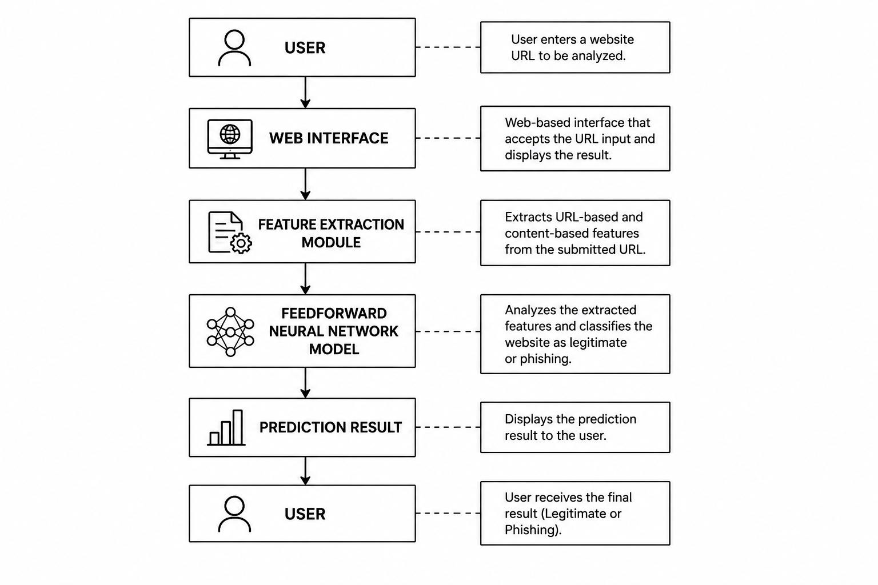
Figure 3.1: System Architecture Diagram of the proposed phishing detection system
3.2.3 Use Case Diagram
The use case diagram shows how the user interacts with the proposed phishing detection system. The main activities available to the user include entering a URL, submitting the URL for analysis, and viewing the prediction result. The diagram also shows the major functions carried out by the system after a URL has been submitted. Figure 3.2 shows the use case diagram of the proposed phishing detection system.

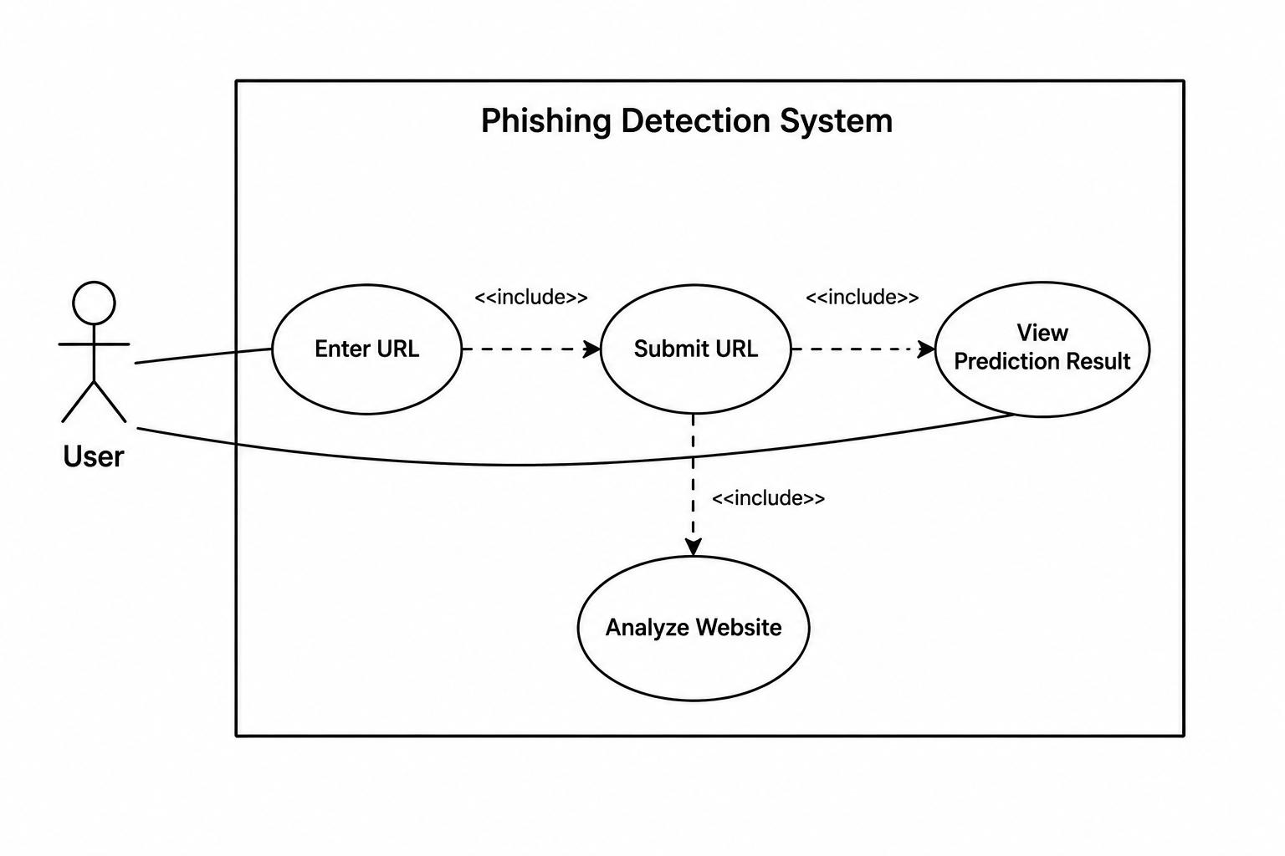
Figure 3.2: Use Case Diagram of the proposed phishing detection system
3.2.4 Activity Diagram
The activity diagram describes the sequence of activities performed by the proposed phishing detection system during operation. It provides a graphical representation of the workflow involved in phishing detection, starting from when a user submits a URL to when the prediction result is displayed. The diagram helps to illustrate how data moves through the different components of the system and how decisions are made during the detection process.
In the proposed system, the process begins when a user enters a URL through the web interface. The system then validates the URL and extracts the required URL-based and content-based features. These extracted features are passed to the feedforward neural network model for analysis. Based on the learned patterns from the training dataset, the model classifies the website as either legitimate or phishing. The prediction result is then displayed to the user through the web interface.
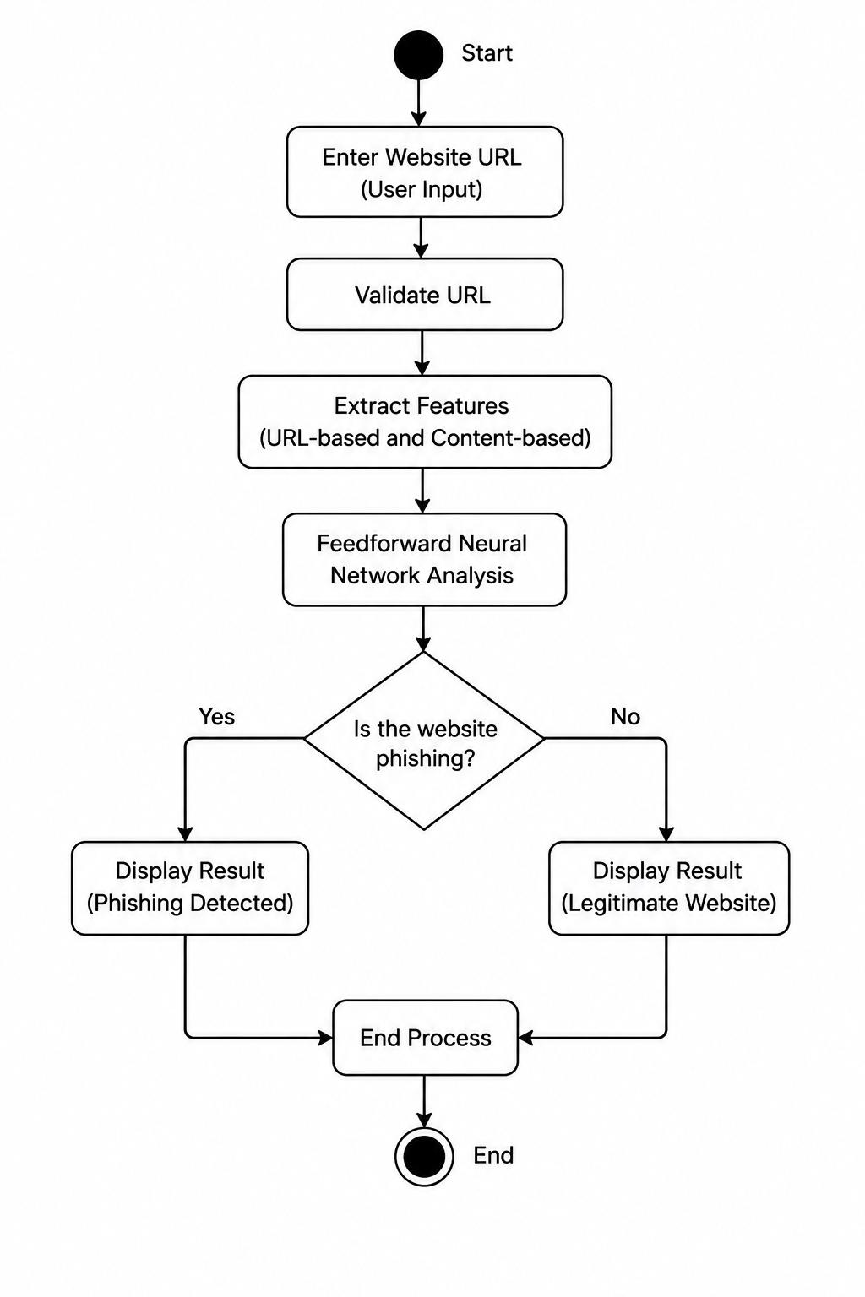
The activity diagram shows a clear view of the operational workflow of the proposed system and helps explain how the different system components interact during phishing detection. Figure 3.3 shows the activity diagram for the proposed phishing detection system.

Figure 3.3: Activity diagram for the proposed phishing detection system.
3.2.5 Input Design
Input design describes the method through which data is entered into the proposed phishing detection system. A good input design helps improve system usability and ensures that the correct information is provided for processing. The proposed phishing detection system is designed with a simple and user-friendly input interface that allows users to submit website URLs for analysis.
The primary input required by the system is the URL of a website that the user wants to verify. Through the web interface, users can enter a URL into the provided input field and submit it for phishing detection. The system then validates the URL and extracts the necessary features required for classifying it as a phishing website or a legitimate website.
The input interface is designed to be simple and easy to understand to reduce user errors. Users are not required to provide technical information or manually extract website features. The system automatically performs the necessary processing after receiving the URL input. This makes the system suitable for both technical and non-technical users.
To improve reliability, the system includes basic input validation mechanisms. These validation checks ensure that empty fields, incomplete URLs, or incorrectly formatted website addresses are detected before processing begins. Appropriate feedback messages are displayed whenever invalid input is entered. Figure 3.4 shows the input interface through which users submit website URLs for phishing analysis.
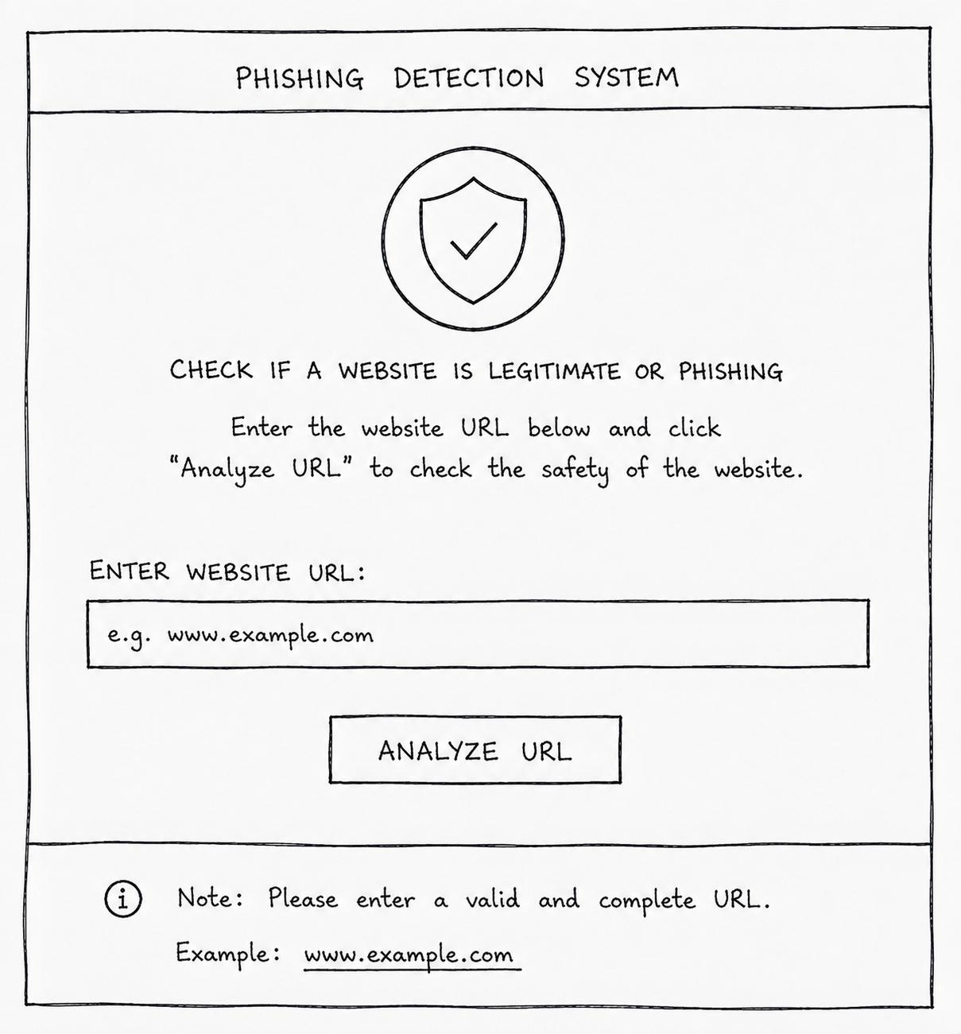
Figure 3.4: Input diagram for the proposed phishing detection system

3.2.6 Output Design
Output design describes how information generated by the system is presented to users after processing has been completed. A good output design ensures that results are displayed clearly to users. The system is designed to provide simple and meaningful output that helps users determine whether a website is legitimate or phishing.
After a website URL has been submitted and analyzed by the feedforward neural network model, the system displays the prediction result through the web interface. The output informs the user whether the submitted website is classified as a phishing website or a legitimate website. This helps users make informed decisions before interacting with potentially harmful websites.
The output interface is designed to be simple and user-friendly. The prediction result is displayed in a clear format that can be easily understood by both technical and non-technical users. Additional information such as confidence scores or prediction probabilities may also be displayed to provide users with more insight into the classification result.
The output design also includes appropriate feedback messages for invalid inputs or processing errors. If a user submits an incorrect or incomplete URL, the system displays an error message explaining the problem and guiding the user towards the correct input format. This helps improve usability and reduces confusion during system operation. Figure 3.6 depicts the output design for this work.

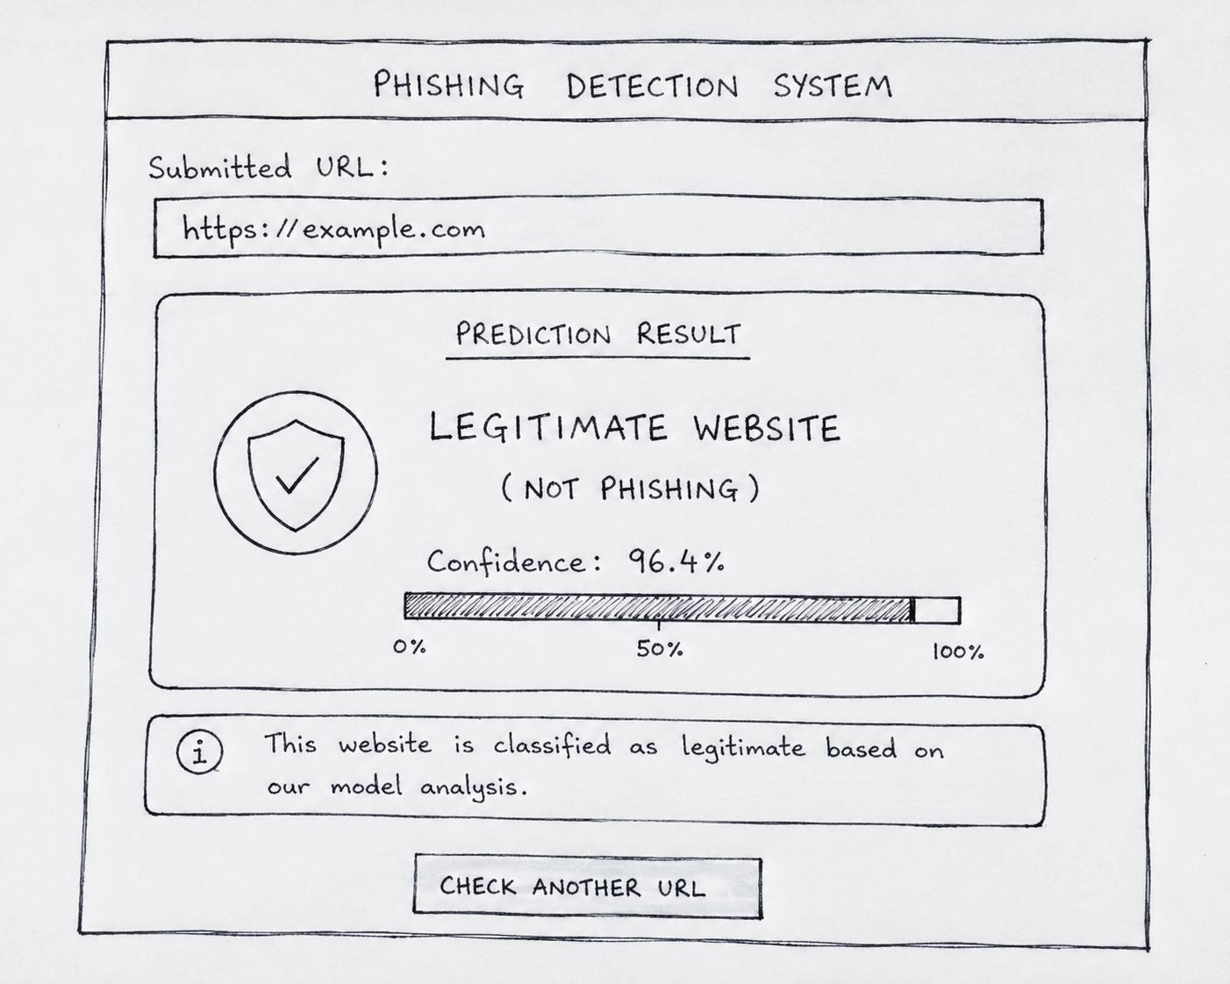

Figure 3.6: Output Design of the Proposed phishing detection system.
3.2.7 Database design
Database design defines the organization, persistence, and synchronization of data generated during system operation. While the core functionality of the proposed system centers on the deep learning inference engine, a cloud-hosted database is integrated to handle dynamic endpoint routing and maintain an audit log of evaluated URLs.
Rather than utilizing a traditional Relational Database Management System (RDBMS) requiring fixed schema overhead, a lightweight NoSQL cloud architecture, Google Firebase Realtime Database, is adopted. Firebase Realtime Database stores data in a structured, tree-like JSON format and provides a native REST API, facilitating asynchronous, low-latency communication between the Google Colab backend server and the web interface.
The database schema is partitioned into two primary functional nodes:
- config Node: Stores dynamic runtime parameters, specifically the transient Localtunnel API endpoint (api_url), ensuring seamless communication between the frontend client and the backend server without manual reconfiguration.
- threats_log Node: Maintains an immutable historical log of all scanned URLs, threat probability scores, classification verdicts, and timestamps for audit and monitoring purposes.
1. Schema Specification for threats_log
Every inference request sent to the /analyze API generates a record within the threats_log node under a unique, 20-character chronologically sorted push key (e.g., -Or9HK8dPvZPwBzpFTLa). The schema attributes are detailed in Table 3.1.
Table 3.1: Data Dictionary for Threats Log (threats_log)
Field Key | Data Type | Description | Example Value
Log_ID (Push Key) | String (Alphanumeric) | Auto-generated 128-bit unique identifier ordered by timestamp | "-Or9HK8dPvZPwBzpFTLa"
url_payload | String (Text) | The target URL submitted by the client for analysis | "URL: [https://x.com/status/](https://x.com/status/)"
threat_score | Float | Raw sigmoid probability output from the neural network ($0.0000 - 1.0000$) | 0.0052
confidence_score | String (Formatted) | Percentage confidence level of the predicted class | "99.48%"
verdict | String (Enum) | Binary decision status (PHISHING DETECTED or LEGITIMATE WEBSITE) | "LEGITIMATE WEBSITE"
timestamp | String (DateTime) | Timestamp recording when the scan occurred | "08/20/2026, 03:54:55 PM"

3.2.8 Model Design
The model design describes the structure of the feedforward neural network used in the proposed phishing detection system. The model serves as the main classification component of the system and is responsible for determining whether a website is legitimate or phishing based on the features extracted from the submitted URL and webpage content.
The proposed model is a Feedforward Neural Network. A feedforward neural network is a type of artificial neural network in which information moves in one direction, from the input layer through one or more hidden layers to the output layer. Unlike some advanced neural network architectures, there are no feedback connections between layers. As shown in Figure 3.6, the proposed model consists of an input layer, hidden layers, and an output layer through which the extracted features are processed to produce the final classification. This simple structure makes the model easier to implement while still providing good performance for classification tasks.
The model receives URL-based and content-based features extracted from websites as input. These features include URL length, presence of special characters, domain-related attributes, HTTPS status, and webpage content characteristics. These features are passed into the input layer shown in Figure 3.6, where they serve as the input data for the neural network.
The hidden layers perform the main learning process within the network. During training, the neurons in these layers learn relationships between the extracted features and the target classification labels. As illustrated in Figure 3.6, the hidden layers receive the processed information from the input layer and pass it forward for further processing. The hidden layers enable the model to identify patterns that may not be easily detected using traditional rule-based or blacklist-based approaches.
The output layer produces the final classification result. The model predicts whether the submitted website belongs to the phishing class or the legitimate class. The final stage of the model, as shown in Figure. 3.6, is the output layer, which produces the classification result that is later displayed to the user through the web interface.
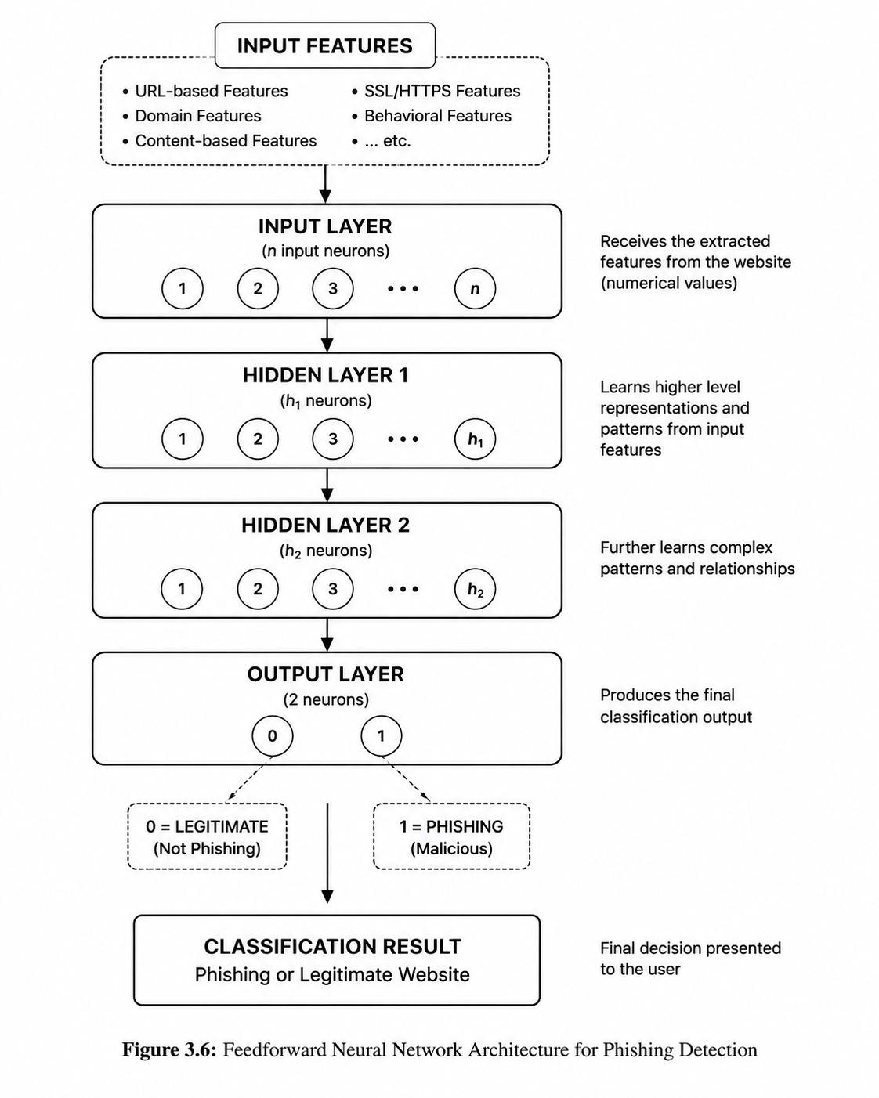

Figure 3.6: Feedforward neural network architecture for phishing decision
3.3 Datasets and Feature Selection Engineering
3.3.1 Dataset Description
The dataset used for this study was obtained from Kaggle and is based on the Mendeley Data phishing website dataset (Vrbančič, 2020). The dataset contains website samples represented by extracted features and a target column labelled phishing, which was used to identify whether a website was phishing or legitimate. The dataset contains 88,647 instances and 112 columns in total.
Out of the 112 columns, the phishing column was used as the target variable, while the remaining 111 columns contained features describing different characteristics of the websites. For the implementation of the true hybrid model, all 111 features were selected as the input features. This encompasses 97 lexical and structural features alongside 14 active network-based and content features, including features related to WHOIS, DNS, and HTTP response metrics. The selected features were highly suitable for the developed web-based system because they dynamically combine local URL text extraction with external network queries to comprehensively evaluate a website's hosting infrastructure in real-time. The summary of the datasets used are shown in Table 3.2.
TABLE 3.2: Summary of the Datasets used in the Study
Dataset Attribute | Description
Dataset Source | Mendeley Data Dataset, accessed through Kaggle and implemented using the dataset file hosted in a GitHub repository
Number of instances | 88,647
Total Number of Columns | 112 (111 predictor features + 1 target variable)
Target Variable | Phishing
Classification Classes | Phishing (1) and Legitimate (0)
Model Used | Feedforward Neural Network (FNN)

3.3.2 Dataset Preprocessing
Before training the FNN model, the dataset was prepared to ensure that the input data was in a suitable form for the model. The preprocessing stage began by separating the selected 111 input features from the target variable, phishing. The selected features were used as the model input, while the target variable represented the classification of each website as either phishing or legitimate.
The dataset was then divided into training and testing sets using an 80:20 split. The training set was used to train the FNN model, while the testing set was reserved for evaluating its performance on previously unseen data. To ensure that the numerical features were on a similar scale, StandardScaler was applied to standardize the training data. The same scaler was subsequently used to transform the testing data. This helped to maintain consistency between the data used during training and evaluation.
Overall, the preprocessing stage involved feature and target separation, train-test splitting, and feature standardization. These steps prepared the selected dataset features for effective use by the FNN model.
3.3.3 Feature Engineering and Selection
Feature selection and engineering were carried out to ensure that the model used features that were suitable for robust, real-time phishing detection. The implementation utilized the complete set of 111 features, forming a hybrid profile that pairs 97 static lexical features (extracted directly from the submitted URL) with 14 active network features (gathered via live WHOIS, DNS, and HTTP response operations).
The feature engineering process involved extracting numerical characteristics from different parts of the submitted URL and its host infrastructure. These characteristics were grouped into seven categories: URL features, domain features, directory features, file features, parameter features, a general feature, and network/content features. Examples of the extracted characteristics include the number of special characters, URL length, domain length, the presence of an IP address in the domain, live domain age, and the presence of an email address within the URL. The selected features were structured as shown in Table 3.3.
TABLE 3.3: Categories of Selected Features used by the FNN Model
Feature Category | Number of Features | Examples of Extracted Characteristics
URL Features | 19 | Special character counts and URL length
Domain Features | 21 | Domain length, vowel count, IP address presence
Directory Features | 18 | Character counts and directory length
File Features | 18 | Character counts and file length
Parameter Features | 20 | Character counts, parameter length and query characteristics
General Features | 1 | Presence of an email address in the URL
Network & Content Features | 14 | Domain age, DNS records, SSL certificates, HTTP redirects
Total | 111

The final set of 111 features was used as input to the FNN model during training and was also extracted dynamically from URLs submitted through the web application during real-time analysis. This ensured that the features used by the deployed system were consistent with those used during model training.

CHAPTER FOUR
SYSTEM IMPLEMENTATION AND RESULTS
4.1 Chapter Overview
This chapter presents the implementation of the proposed hybrid deep learning system for phishing detection. It describes the hardware and software environments used to develop and implement the system as a functional web-based prototype. The chapter also discusses the testing strategies used to evaluate the system, including unit and integration testing. The performance of the model is presented using relevant evaluation metrics to assess its ability to distinguish between legitimate and phishing websites. The chapter concludes with a discussion of the results obtained from the implemented system and what they indicate about its effectiveness.
4.2 Implementation Environment
The proposed hybrid deep learning phishing detection system was implemented using a combination of software tools, machine learning libraries, cloud computing resources, and web development technologies. These tools provided the environment needed to develop, train, test, and deploy the model as a web-based system. The choice of an appropriate implementation environment is important because the available computational resources and software tools can affect the efficiency of model training and system performance (Ibor et al., 2022). The implementation environment was divided into three main areas: the software environment and libraries, the cloud infrastructure and API middleware, and the frontend environment.
1. Software Environment and Libraries
Python was used as the main programming language for the backend because of its wide range of libraries for machine learning and data analysis. The Feedforward Neural Network model was developed, trained, and evaluated using TensorFlow and Keras. Pandas and NumPy were used for data handling and numerical operations, while Scikit-learn was used for data preprocessing, feature extraction, and feature scaling on the Mendeley dataset. Additionally, networking libraries such as dnspython, python-whois, and requests were incorporated to handle the real-time extraction of live network and DNS telemetry.
2. Cloud Infrastructure and API Middleware
Due to the limitations of the available local hardware, Google Colaboratory (Colab) was used as the main development environment for training the model. Colab provided access to virtual computing resources, including CPU and RAM, which supported the processing of the 111-feature dataset and the training of the neural network.
For the deployment of the trained model, FastAPI was used to develop the backend API. The API receives URL submissions from the frontend, processes them using the trained model, and returns the predicted result and confidence score. Localtunnel was used to create a public connection between the backend and the web interface, allowing URL submissions from the frontend to reach the deployed model.
Google Firebase Realtime Database was also used as the NoSQL database for storing system records, including submitted URLs and their corresponding results.
3. Frontend Environment
The frontend was developed using HTML5, CSS3, and JavaScript to provide a simple and interactive web interface. The Fetch API was used to send user-submitted URLs to the FastAPI backend without requiring the webpage to reload. The response from the backend was then displayed on the interface, showing the classification result and confidence score to the user.
4.3 System Testing Strategies
System testing is an important part of the software development process, especially in cybersecurity applications where errors in detection can affect the reliability of the system. Proper testing helps to ensure that the different components of a system work as expected and that the system can effectively perform its intended function (Ibor et al., 2018). For this project, testing was carried out using unit testing and integration testing. These tests were used to check the individual components of the system and ensure that they work correctly when combined. The testing focused on the data processing pipeline, the machine learning model, the backend API, and the communication between the frontend and backend.
4.3.1 Unit Test
Unit testing was carried out to test the individual components of the system separately and ensure that each component worked correctly before being combined with the others. For this project, the unit testing focused mainly on the backend functions, data processing, model inference, and database connectivity.
  - Feature Extraction Validation: The custom extract_97_features() Python function was tested using known benign and malicious URLs, such as google.com and transfer406.pages.dev. This was done to confirm that the URL processing and canonicalization worked correctly and that the 97 structural features, including domain length, symbol counts, and parameter-related features, were extracted accurately without causing errors. The additional 14 network and content-related features, including information obtained from DNS records, SSL certificates, and HTTP redirects, were also tested to ensure that they were properly extracted and combined with the URL-based features for classification.
  - Model Inference Test: The trained deep learning model (fnn_phishing_model.h5) and the scaler (scaler.pkl) were tested locally using sample data arrays. This test confirmed that the model was able to process the input data and return a valid sigmoid probability value between 0.0 and 1.0.
  - Database Connectivity Test: A separate test script was used to send a sample JSON payload to the Firebase Realtime Database. This confirmed that the database could receive the request successfully and generate a unique push key without authentication errors.

4.3.2 Integration Test
Integration testing was carried out to ensure that the different components of the system worked correctly when connected. The tests focused on the flow of data from the frontend through the FastAPI backend and machine learning model, and finally back to the user interface. The following integration tests were performed.
- Client-Server Communication: The web frontend, developed with HTML and JavaScript, was tested to ensure that it could successfully send a submitted URL to the FastAPI backend through the Localtunnel URL.
- End-to-End Pipeline: A URL was entered through the frontend dashboard and the complete process was observed. The test confirmed that the FastAPI server received the URL, passed it to the feature extraction function, scaled the extracted features, and sent them to the trained model for prediction. The prediction was then returned to the frontend as a JSON response containing the confidence score and the classification result.
- Asynchronous Logging and UI Rendering: The final integration test checked that the system could record the prediction in the Firebase threats_log node after a successful classification. At the same time, the frontend was tested to ensure that it updated the page automatically with the appropriate result, using a red indicator for phishing and a green indicator for legitimate websites, without requiring the page to be refreshed.
4.4 Software and Hardware Requirements
The proposed system requires software tools for model development, data processing, and web application development. It also requires basic computer hardware for training, testing, and running the system. The following software will be used:
1. Python: Python will be used as the main programming language for developing the phishing detection model. It will also be used for data preprocessing, feature extraction, and implementing the feedforward neural network.
- TensorFlow/Keras: These frameworks will be used for building, training, and evaluating the feedforward neural network model. They provide the necessary functions for creating neural network layers and improving the model during training.
- Flask: Flask will be used as the web application framework for connecting the trained model with the user interface. It will allow users to submit website URLs and receive prediction results through the web-based prototype.
- HTML and CSS: HTML will be used to create the structure of the web pages, while CSS will be used to improve the appearance and layout of the user interface.
- JavaScript: JavaScript will be used where necessary to improve the interaction between the user and the web interface.
- Pandas and NumPy: These libraries will be used for handling datasets, performing data processing operations, and carrying out numerical computations required during model development.
- Scikit-learn: This library will be used for dataset preparation, feature processing, and evaluating the performance of the machine learning model.
- Web Browser: A modern web browser such as Google Chrome will be used for accessing and testing the developed phishing detection system.
The hardware requirements describe the physical resources required for developing and running the proposed system. The following hardware components will be required:
- Computer System: A laptop or desktop computer will be used for system development, dataset processing, model training, and testing.
- Processor: A processor equivalent to Intel Core i3 or higher is required to support programming activities and model execution.
- Memory (RAM): A minimum of 4GB RAM is required to allow smooth execution of the development tools and system components.
- Storage: Adequate storage space is required for storing datasets, development files, and the trained model.
- Internet Connection: Internet access is required for downloading datasets, accessing development resources, and testing the web-based system.
- Input and Output Devices: A keyboard, mouse, and display screen are required for system development and interaction.
The software and hardware requirements listed above provide a suitable environment for the development and operation of the proposed phishing detection system.
4.5 Target Computer System Requirements
Since the major computational tasks, such as model training and data processing, are carried out using cloud-based resources such as Google Colaboratory and Firebase, the system does not require high computing power from the user’s computer. The user only needs a device that can access the web application and communicate with the backend through the internet.
The requirements for accessing and using the phishing detection system are as follows:
- Operating System: The system can be accessed using modern operating systems, including Windows, macOS, Linux, Android, and iOS.
- Hardware: A computer or mobile device with at least 2 GB of RAM and a basic multi-core processor, such as an Intel Core i3 or an equivalent processor, is sufficient for accessing the system.
- Software: A modern web browser with JavaScript enabled, such as Google Chrome, Mozilla Firefox, Microsoft Edge, or Apple Safari, is required.
- Network: A stable internet connection is required to submit URLs to the FastAPI backend and receive the classification results from the system.
- For the system administrator or developer, a computer with internet access is required to access Google Colaboratory, run the Python code, and manage the backend and Localtunnel connection.

4.6 Results
The implementation of the proposed hybrid deep learning phishing detection system was successfully completed, and the system was able to classify submitted websites as either phishing or legitimate in real time. The Feedforward Neural Network (FNN) was trained using the 111 features extracted from the dataset, which included URL-related characteristics such as lexical, domain, file, parameter, and active network features. The trained model was integrated with the FastAPI backend and the web interface, allowing users to submit URLs and receive a classification result and confidence score. Firebase was also integrated to store the results generated by the system.
4.6.1 Model Performance and Evaluation Metrics
To evaluate the performance of the trained deep learning model, standard classification metrics were calculated using the 20% unseen testing dataset. These metrics were used to determine how well the model could distinguish between phishing and legitimate websites. They also provided a clearer view of the model’s performance beyond accuracy alone, particularly in terms of correctly identifying phishing websites and avoiding incorrect classifications (Udeze, Eteng, & Ibor, 2022). To measure the performance of the Feedforward Neural Network (FNN) model, the evaluation metrics were calculated from the results obtained from the confusion matrix. Since the system performs binary classification, the metrics are based on True Positives (TP), True Negatives (TN), False Positives (FP), and False Negatives (FN). These values were used to calculate the Accuracy, Precision, Recall, and F1-Score of the phishing detection model.
The evaluation metrics used were:
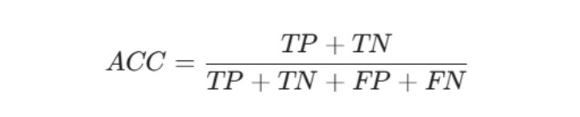
- Accuracy: This measures the proportion and gives the overall percentage of correct predictions made by the model, including websites correctly classified as either phishing or legitimate.
(1)


- False Positive Rate (FPR): False Positive Rate shows how often legitimate websites are wrongly classified as phishing. A lower FPR means the system is less likely to raise false alarms against legitimate websites.
(2)

- Precision: This measures the proportion of websites predicted as phishing that were actually phishing. A high precision value indicates that the system produces fewer false alarms by reducing the number of legitimate websites incorrectly classified as phishing.
(3)

- Recall (Sensitivity): This measures the proportion of actual phishing websites that were correctly identified by the model. A high recall value means that the system is able to identify most of the phishing websites in the dataset.
(4)
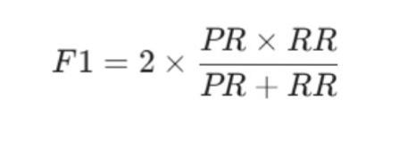
- F1-Score: F1-Score combines precision and recall to give a single measure of the model’s overall classification performance. It is useful because the model needs to detect phishing websites effectively while also avoiding unnecessary false alarms.
(5)
- Binary Cross-Entropy Loss: This measures the difference between the probabilities predicted by the model and the actual class labels. A lower loss indicates that the predicted probabilities are closer to the actual labels.
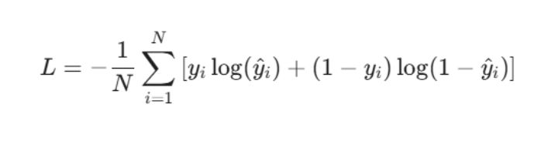
- Validation Loss (L – Binary Cross-Entropy): Validation loss shows how closely the model’s predicted probabilities match the actual labels in the validation data. Binary Cross-Entropy was used for this purpose, where a lower loss indicates that the model’s predictions are closer to the expected results.
(6)
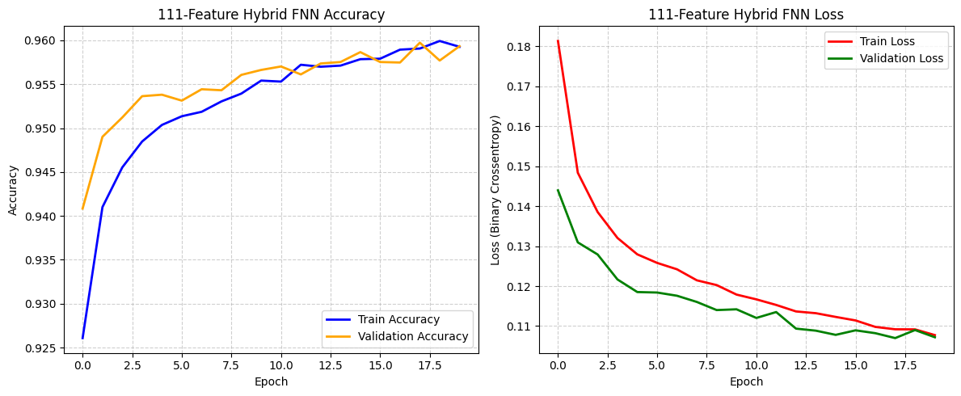
Figure 4.1: Training and Validation Accuracy and Loss of the FNN Model Across Epochs
As shown in Figure 4.1, both the training and validation accuracy remained relatively high throughout the training process, with the accuracy generally increasing across the epochs. The training and validation loss also decreased over time, indicating that the model was learning and improving its predictions. The relatively close performance of the training and validation curves suggests that the model did not show a clear sign of overfitting during training. To further quantify the model’s precision, a Confusion Matrix was generated to map the true positives (correctly identified phishing websites) against false positives (legitimate websites incorrectly flagged as phishing).
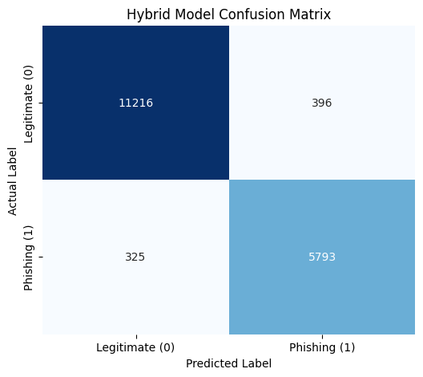
Figure 4.2: Confusion Matrix showing the true positive, true negative, false positive, and false negative classification rates.
The values from the confusion matrix were used to evaluate the performance of the FNN model and determine how well it classified legitimate and phishing websites. Since accuracy alone may not fully reflect the model’s performance, especially when considering false positives and false negatives, the system was further evaluated using Precision, Recall, and F1-Score, as presented in Table 4.3.

TABLE 4.3: Performance Evaluation of the FNN Phishing Detection Model
Evaluation Metric | Result
Accuracy | 95.93%
False Positive Rate (FPR) | 3.41%
Precision | 93.60%
Recall Rate (Sensitivity) | 94.69%
F1 Score | 94.14%
Validation Loss | 0.1081

4.6.2 System Deployment and Real-Time Interception
The trained FNN model was integrated into the developed web application to test its ability to classify submitted URLs in real time. The machine learning backend was connected to the frontend through the FastAPI API, allowing users to submit URLs and receive the classification result and confidence score through the web interface.

Fig. 4.3: Deployed Phishing Detection System Dashboard

Figure 4.3 shows the dashboard of the developed phishing detection system. The dashboard provides an interface where users can enter a URL for analysis. Once a URL is submitted, it is sent to the backend for feature extraction and classification by the trained FNN model. The resulting prediction and confidence score are then returned and displayed on the dashboard.

Fig. 4.4 System correctly classifying a legitimate website.
As shown in Figure 4.4, a legitimate website was submitted through the phishing detection system for real-time classification. The system correctly identified the website as legitimate and displayed a confidence score of 95.25% on the dashboard, demonstrating that the system can correctly classify legitimate websites during real-time use.

Fig. 4.5 System correctly identifying a phishing website
As shown in Figure 4.5, a phishing website was submitted through the system for real-time classification. The system processed the URL and correctly identified it as phishing, displaying a confidence score of 77.05% on the dashboard. This demonstrates the ability of the developed system to detect potentially malicious websites and provide an immediate classification result to the user.
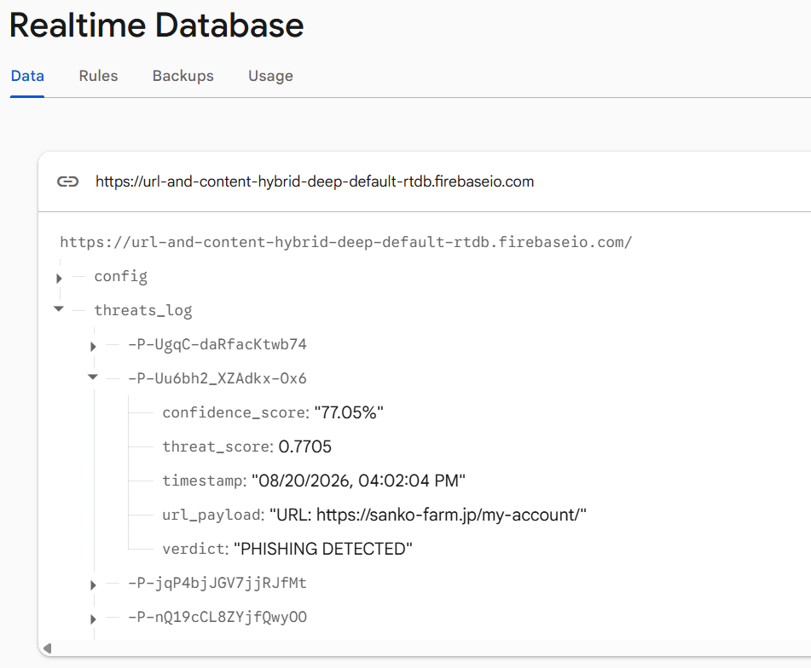
Fig. 4.6 Firebase Realtime Database Showing System Threat Logs.
Figure 4.6 shows the threat logs stored in the Firebase Realtime Database after URLs have been processed by the system. The database records important details from each classification, including the submitted URL, the classification result, confidence score, and time of analysis. This allows the results generated by the system to be stored and reviewed when needed, providing a record of the activities carried out during real-time URL analysis.

4.7 Discussion
The results show that the FNN model was able to classify phishing and legitimate websites with exceptional accuracy. The model recorded an accuracy of 95.93%, while the precision, recall, and F1-Score were 93.60%, 94.69%, and 94.14%, respectively. The 3.41% False Positive Rate also shows that the system did not frequently classify legitimate websites as phishing. From these results, I found that the model was able to learn highly distinct structural and infrastructural patterns from the hybrid features used for the classification.
The confusion matrix gives a clearer view of the model's performance. From a testing subset of 17,730 total instances, the model correctly identified 5,793 phishing websites and 11,216 legitimate websites. However, 325 phishing websites were classified as legitimate, while 396 legitimate websites were incorrectly classified as phishing. The false negatives are particularly important because they represent phishing websites that the system failed to detect. This shows that although the model performed remarkably well overall, there is still minor room to improve its ability to detect heavily cloaked phishing websites.
The training results also showed a fairly stable performance across the epochs. Both the training and validation accuracy remained relatively high, while the training and validation loss generally decreased as the training progressed. I did not observe a clear sign of severe overfitting from the training curves, as the validation performance remained reasonably close to the training performance.
The model was also successfully connected to the developed web application for real-time URL classification. A user can enter a URL through the dashboard, after which it is sent to the backend for hybrid feature extraction and classification by the trained FNN model. The result and confidence score are then displayed on the dashboard. Firebase Realtime Database was also integrated to store the classification results, including the URL, classification, confidence score, and time of analysis. This makes it possible to keep a record of the URLs that have been analyzed by the system.
Overall, the results show that the developed system provides a practical and advanced approach to phishing detection. Although a small margin of phishing and legitimate websites were incorrectly classified, the model achieved an outstanding level of performance and was successfully integrated into a working web application. I believe the combination of lexical and network-based feature extraction with the FNN model, alongside the web interface, provides a robust foundation for detecting phishing websites in real time.

CHAPTER FIVE
SUMMARY, RECOMMENDATION AND CONCLUSION
  - Chapter Overview
This chapter presents the summary, recommendations, and conclusion of the study. It briefly reviews the work carried out in developing the proposed phishing detection system, highlights the major findings, and provides recommendations for improving the system in future research.

  - Summary
This study focused on the development of a URL and content hybrid deep learning model for phishing detection. The study examined the challenges associated with traditional phishing detection methods and explored the use of deep learning to improve the identification of phishing websites. A Feedforward Neural Network (FNN) was developed and trained using the selected features from the dataset, after which the model was evaluated using accuracy, False Positive Rate, precision, recall, F1-Score, and validation loss. The model achieved an accuracy of 95.93%, with a precision of 93.60%, recall of 94.69%, F1-Score of 94.15%, and a False Positive Rate of 3.41%. The trained model was also integrated into a web-based application using FastAPI, allowing users to submit URLs and receive classification results and confidence scores in real time. Firebase Realtime Database was integrated to store the results of the analyses. From the implementation and evaluation, the developed system can provide a practical approach to identifying phishing websites.

  - Recommendations
Based on the results of this study, future research can focus on improving the model’s ability to detect phishing websites that are incorrectly classified as legitimate. This can be achieved by using larger and more diverse datasets containing newer phishing techniques and regularly updated website features. Future work could also explore other deep learning models, such as Convolutional Neural Networks (CNN), Recurrent Neural Networks (RNN), or Long Short-Term Memory (LSTM), and compare their performance with the FNN model. Also, the system can be improved by incorporating more webpage content features, improving real-time deployment, and developing browser-based or mobile extensions that can automatically analyze websites as users visit them.

  - Conclusion and Future Research Direction
The study successfully developed and implemented a deep learning-based phishing detection system capable of classifying websites as phishing or legitimate in real time. The FNN model achieved a good overall performance, while its integration with FastAPI and Firebase allowed the model to be connected to a functional web interface and store classification results. Although the system still produced some false positives and false negatives, the results show that deep learning can be applied effectively to phishing detection. This developed system provides a useful foundation for further improvements in automated phishing detection and can be extended in future work to handle more complex and evolving phishing techniques.

REFERENCES
Abdelhamid, N., Ayesh, A., & Thabtah, F. (2014). Phishing detection based associative classification data mining. Expert Systems with Applications, 41(13), 5948–5959. https://doi.org/10.1016/j.eswa.2014.03.019
Aburrous, M., Hossain, M. A., Dahal, K., & Thabtah, F. (2010). Intelligent phishing detection system for e-banking using fuzzy data mining. Expert Systems with Applications, 37(12), 7913–7921. https://doi.org/10.1016/j.eswa.2010.04.044
Adebowale, M. A. (2023). An intelligent phishing detection and protection scheme using a fusion of images, frames and text [Doctoral dissertation, Anglia Ruskin University]. Anglia Ruskin Research Online.
Adebowale, M. A., Lwin, K. T., & Hossain, M. A. (2023). Intelligent phishing detection scheme using deep learning algorithms. Journal of Enterprise Information Management, 36(3), 747–766. https://doi.org/10.1108/JEIM-01-2020-0036
Alkhalil, Z., Hewage, C., Nawaf, L., & Khan, I. (2021). Phishing attacks: A recent comprehensive study and a new anatomy. Frontiers in Computer Science, 3, Article 563060. https://doi.org/10.3389/fcomp.2021.563060
Basit, A., Zafar, M., Liu, X., Javed, A. R., Jalil, Z., & Kifayat, K. (2021). A comprehensive survey of AI-enabled phishing attacks detection techniques. Telecommunication Systems, 76(1), 139–154. https://doi.org/10.1007/s11235-020-00733-2
Catal, C., Giray, G., Tekinerdogan, B., Kumar, S., & Shukla, S. (2022). Applications of deep learning for phishing detection: A systematic literature review. Knowledge and Information Systems, 64(6), 1457–1500. https://doi.org/10.1007/s10115-022-01672-x
Chiew, K. L., Yong, K. S. C., & Tan, C. L. (2018). A survey of phishing attacks: Their types, vectors, and technical approaches. Expert Systems with Applications, 106, 1–20. https://doi.org/10.1016/j.eswa.2018.03.050
Fang, Y., Zhang, C., Huang, C., Liu, L., & Yang, Y. (2019). Phishing email detection using improved RCNN model with multilevel vectors and attention mechanism. IEEE Access, 7, 56329–56340. https://doi.org/10.1109/ACCESS.2019.2913705
Gupta, B. B., Arachchilage, N. A. G., & Psannis, K. E. (2018). Defending against phishing attacks: Taxonomy of methods, current issues and future directions. Telecommunication Systems, 67(2), 247–267. https://doi.org/10.1007/s11235-017-0334-z
Ibor, A. E., Okunoye, O. B., Oladeji, F. A., & Abdulsalam, K. A. (2022). Novel hybrid model for intrusion prediction on cyber physical systems’ communication networks based on bio-inspired deep neural network structure. Journal of Information Security and Applications, 65, Article 103107. https://doi.org/10.1016/j.jisa.2022.103107
Ibor, A. E., Oladeji, F. A., & Okunoye, O. B. (2018). A survey of cyber security approaches for attack detection prediction and prevention. International Journal of Security and Its Applications, 12(4), 15–28.
Ibor, A. E., Oladeji, F. A., Okunoye, O. B., & Ekabua, O. O. (2020). Conceptualisation of cyberattack prediction with deep learning. Cybersecurity, 3, Article 14. https://doi.org/10.1186/s42400-020-00053-5
Jain, A. K., & Gupta, B. B. (2018). Towards detection of phishing websites on client-side using machine learning. Telecommunication Systems, 68(4), 687–700. https://doi.org/10.1007/s11235-017-0414-0
Ma, J., Saul, L. K., Savage, S., & Voelker, G. M. (2009). Beyond blacklists: Learning to detect malicious web sites from suspicious URLs. In Proceedings of the 15th ACM SIGKDD International Conference on Knowledge Discovery and Data Mining (pp. 1245–1254). Association for Computing Machinery. https://doi.org/10.1145/1557019.1557153
Mao, J., Bian, J., Tian, W., Zhu, S., Wei, T., Li, A., & Liang, Z. (2019). Phishing page detection via learning classifiers from page layout feature. EURASIP Journal on Wireless Communications and Networking, 2019, Article 43. https://doi.org/10.1186/s13638-019-1361-0
Mao, J., Tian, W., Li, P., Wei, T., & Liang, Z. (2017). Phishing-alarm: Robust and efficient phishing detection via page component similarity. IEEE Access, 5, 17020–17030. https://doi.org/10.1109/ACCESS.2017.2739379
Moghimi, M., & Varjani, A. Y. (2016). New rule-based phishing detection method. Expert Systems with Applications, 53, 231–242. https://doi.org/10.1016/j.eswa.2016.01.028
Odeh, A., Keshta, I., & Abdelfattah, E. (2021). Machine learning techniques for detection of website phishing: A review for promises and challenge. In 2021 IEEE 11th Annual Computing and Communication Workshop and Conference (CCWC) (pp. 813–818). IEEE. https://doi.org/10.1109/CCWC51732.2021.9375997
Rao, R. S., & Pais, A. R. (2019). Detection of phishing websites using an efficient feature-based machine learning framework. Neural Computing and Applications, 31(8), 3851–3873. https://doi.org/10.1007/s00521-017-3305-0
Sahingoz, O. K., Buber, E., Demir, O., & Diri, B. (2019). Machine learning based phishing detection from URLs. Expert Systems with Applications, 117, 345–357. https://doi.org/10.1016/j.eswa.2018.09.029
Salahdine, F., & Kaabouch, N. (2019). Social engineering attacks: A survey. Future Internet, 11(4), Article 89. https://doi.org/10.3390/fi11040089
Udeze, C. L., Eteng, I. E., & Ibor, A. E. (2022). Application of machine learning and resampling techniques to credit card fraud detection. Journal of the Nigerian Society of Physical Sciences, Article 769.
Vrbančič, G. (2020). Phishing websites dataset (Version 1) [Data set]. Mendeley Data. https://doi.org/10.17632/72ptz43s9v.1
Xiang, G., Hong, J., Rose, C. P., & Cranor, L. (2011). CANTINA+: A feature-rich machine learning framework for detecting phishing web sites. ACM Transactions on Information and System Security, 14(2), Article 21.
Yang, P., Zhao, G., & Zeng, P. (2019). Phishing website detection based on multidimensional features driven by deep learning. IEEE Access, 7, 15196–15209. https://doi.org/10.1109/ACCESS.2019.2892066
Zhang, Y., Hong, J. I., & Cranor, L. F. (2007). CANTINA: A content-based approach to detecting phishing websites. In Proceedings of the 16th International World Wide Web Conference (WWW ’07) (pp. 639–648). Association for Computing Machinery. https://doi.org/10.1145/1242572.1242659

APPENDIX
This appendix contains the source code used in the development and implementation of the proposed URL and content hybrid phishing detection system. The code is divided into the backend and frontend components of the system.

Appendix A: Backend Source Code
This section presents the backend source code responsible for URL feature extraction, model inference, API communication, and storage of analysis results in the Firebase Realtime Database.

Backend Deep Learning API
6 cells on google collab follow this logical flow

Cell 1
!pip install fastapi uvicorn nest-asyncio pydantic tldextract beautifulsoup4 scikit-learn python-whois dnspython requests
!npm install -g localtunnel

Cell 2
import pandas as pd
import numpy as np
import pickle
import tensorflow as tf
from tensorflow.keras.models import Sequential
from tensorflow.keras.layers import Dense, Dropout
from sklearn.model_selection import train_test_split
from sklearn.preprocessing import StandardScaler

print("TensorFlow Version:", tf.__version__)

# 1. LOAD FULL DATASET
dataset_url = 'https://raw.githubusercontent.com/biggmanuel/URL-and-Content-Hybrid-Deep/refs/heads/main/dataset_full.csv'
print(f"\nDownloading dataset from: {dataset_url}")
df = pd.read_csv(dataset_url)
# 2. ISOLATE ALL 111 FEATURES (LEXICAL + NETWORK/CONTENT)
X = df.iloc[:, :-1].values
y = df['phishing'].values
feature_count = X.shape[1]

print(f"Model will now learn from the full {feature_count}-feature Hybrid set.")

X_train, X_test, y_train, y_test = train_test_split(X, y, test_size=0.2, random_state=42)

scaler = StandardScaler()
X_train_scaled = scaler.fit_transform(X_train)
X_test_scaled = scaler.transform(X_test)

# 3. BUILD THE FEEDFORWARD NEURAL NETWORK (FNN)
tf.random.set_seed(42)
model = Sequential([
Dense(128, activation='relu', input_shape=(feature_count,)),
Dropout(0.3),
Dense(64, activation='relu'),
Dropout(0.2),
Dense(32, activation='relu'),
Dense(1, activation='sigmoid')
])

model.compile(loss='binary_crossentropy', optimizer='adam', metrics=['accuracy'])

# 4. TRAIN THE MODEL
print("\n--- Starting Model Training ---")
history = model.fit(
X_train_scaled, y_train,
epochs=20,
batch_size=64,
validation_data=(X_test_scaled, y_test),
verbose=1
)

# 5. SAVE ARTIFACTS
model.save('fnn_phishing_model.h5')
with open('scaler.pkl', 'wb') as handle:
pickle.dump(scaler, handle, protocol=pickle.HIGHEST_PROTOCOL)

with open('feature_count.txt', 'w') as f:
f.write(str(feature_count))

print("\n✅ 111-Feature Hybrid Model and Scaler successfully saved!")

Cell 3
%%writefile main.py
from fastapi import FastAPI
from pydantic import BaseModel
import tensorflow as tf
import pickle
import numpy as np
import re
import requests
import whois
import dns.resolver
import time
from datetime import datetime
from urllib.parse import urlparse
from fastapi.middleware.cors import CORSMiddleware

app = FastAPI()
app.add_middleware(
CORSMiddleware,
allow_origins=["*"],
allow_credentials=True,
allow_methods=["*"],
allow_headers=["*"]
)

# Load Artifacts
model = tf.keras.models.load_model('fnn_phishing_model.h5')
with open('scaler.pkl', 'rb') as handle:
scaler = pickle.load(handle)

THRESHOLD = 0.50

# Firebase Database Logging Endpoint
FIREBASE_LOG_URL = "https://url-and-content-hybrid-deep-default-rtdb.firebaseio.com/threats_log.json"

class Payload(BaseModel):
url: str

def count_chars(text):
if not text: return [-1] * 17
return [text.count(ch) for ch in ['.', '-', '_', '/', '?', '=', '@', '&', '!', ' ', '~', ',', '+', '*', '#', '$', '%']]

def extract_111_features(url: str):
clean_url = url.strip().lower()
if not clean_url.startswith('http://') and not clean_url.startswith('https://'):
clean_url = 'https://' + clean_url

parsed = urlparse(clean_url)
netloc = parsed.netloc
if netloc.startswith('www.'): netloc = netloc[4:]

# --- 1 to 97: LEXICAL FEATURES ---
f_url = count_chars(clean_url)
f_url.extend([clean_url.count('.') - 1 if clean_url.count('.') > 0 else 0, len(clean_url)])

f_dom = count_chars(netloc)
f_dom.extend([sum(1 for v in netloc if v in 'aeiou'), len(netloc)])
f_dom.extend([1 if re.search(r'\d+\.\d+\.\d+\.\d+', netloc) else 0, 1 if 'server' in netloc or 'client' in netloc else 0])

path = parsed.path

# NORMALIZATION FIX: Strip redundant root trailing slashes
if path == '/':
path = ''

if '/' in path:
directory, file = path.rsplit('/', 1)[0] + '/', path.rsplit('/', 1)[1]
else:
directory, file = '', path

f_dir = count_chars(directory)
f_dir.append(len(directory) if directory else -1)

f_file = count_chars(file)
f_file.append(len(file) if file else -1)

query = parsed.query
f_par = count_chars(query)
f_par.extend([len(query) if query else -1, 1 if query and '.' in query else (0 if query else -1), query.count('=') if query else -1])

lexical_features = f_url + f_dom + f_dir + f_file + f_par + [1 if re.search(r'[a-zA-Z0-9._%+-]+@[a-zA-Z0-9.-]+\.[a-zA-Z]{2,}', clean_url) else 0]

# --- 98 to 111: NETWORK & CONTENT FEATURES ---
time_response = -1
qty_redirects = -1
tls_ssl_certificate = 0

# 1. HTTP Request (Response time, redirects, SSL check)
try:
start_time = time.time()
resp = requests.get(clean_url, timeout=3)
time_response = time.time() - start_time
qty_redirects = len(resp.history)
if resp.url.startswith('https'):
tls_ssl_certificate = 1
except:
pass

# 2. DNS Queries (IPs, NS, MX, SPF)
domain_spf = 0
qty_ip_resolved = -1
qty_nameservers = -1
qty_mx_servers = -1
ttl_hostname = -1
try:
answers_a = dns.resolver.resolve(netloc, 'A', lifetime=2)
qty_ip_resolved = len(answers_a)
ttl_hostname = answers_a.rrset.ttl
except: pass
try: qty_nameservers = len(dns.resolver.resolve(netloc, 'NS', lifetime=2))
except: pass
try: qty_mx_servers = len(dns.resolver.resolve(netloc, 'MX', lifetime=2))
except: pass
try:
txt_records = dns.resolver.resolve(netloc, 'TXT', lifetime=2)
if any('v=spf1' in rdata.to_text() for rdata in txt_records):
domain_spf = 1
except: pass

# 3. WHOIS Query (Domain Age)
time_domain_activation = -1
time_domain_expiration = -1
try:
w = whois.whois(netloc)
creation = w.creation_date[0] if isinstance(w.creation_date, list) else w.creation_date
expiration = w.expiration_date[0] if isinstance(w.expiration_date, list) else w.expiration_date
if creation:
time_domain_activation = (datetime.now() - creation).days
if expiration:
time_domain_expiration = (expiration - datetime.now()).days
except:
pass

# 4. Misc Features
asn_ip = -1
url_google_index = 0
domain_google_index = 0
shorteners = ['bit.ly', 'tinyurl.com', 'goo.gl', 't.co', 'ow.ly', 'is.gd']
url_shortened = 1 if any(s in netloc for s in shorteners) else 0

network_features = [
time_response, domain_spf, asn_ip, time_domain_activation, time_domain_expiration,
qty_ip_resolved, qty_nameservers, qty_mx_servers, ttl_hostname, tls_ssl_certificate,
qty_redirects, url_google_index, domain_google_index, url_shortened
]

return np.array([lexical_features + network_features])

@app.post("/analyze")
async def analyze_api(payload: Payload):
# 1. Run inference
raw_features = extract_111_features(payload.url)
scaled_features = scaler.transform(raw_features)
score = float(model.predict(scaled_features)[0][0])

is_phishing = score >= THRESHOLD
confidence_val = (score if is_phishing else (1.0 - score)) * 100.0

# 2. Format record for Firebase
timestamp_str = datetime.now().strftime("%m/%d/%Y, %I:%M:%S %p")
log_entry = {
"url_payload": f"URL: {payload.url}",
"confidence_score": f"{confidence_val:.2f}%",
"threat_score": round(score, 4),
"verdict": "PHISHING DETECTED" if is_phishing else "LEGITIMATE WEBSITE",
"timestamp": timestamp_str
}

# 3. Push to Firebase Realtime Database
try:
requests.post(FIREBASE_LOG_URL, json=log_entry, timeout=3)
except Exception as e:
print(f"⚠️ Firebase logging error: {e}")

return {
"scanned_url": payload.url,
"threat_score": round(score, 4),
"is_phishing": is_phishing
}

Cell 4
import urllib.request
import nest_asyncio
import uvicorn
import threading
import subprocess
import requests
import time

# 1. Get your LocalTunnel password (You will need this to access the web link)
endpoint_ip = urllib.request.urlopen('https://ipv4.icanhazip.com').read().decode('utf8').strip()
print(f"*** YOUR LOCALTUNNEL PASSWORD IS: {endpoint_ip} ***\n")

# 2. Run the FastAPI server in the background
def run_app():
nest_asyncio.apply()
uvicorn.run("main:app", host="0.0.0.0", port=8000, log_level="critical")

thread = threading.Thread(target=run_app, daemon=True)
thread.start()

# Give the server a second to start
time.sleep(2)

# 3. Start Localtunnel and capture the generated URL
print("Starting Localtunnel and waiting for URL...")
process = subprocess.Popen(["npx", "localtunnel", "--port", "8000"], stdout=subprocess.PIPE)

tunnel_url = ""
for line in iter(process.stdout.readline, b''):
output = line.decode("utf-8").strip()
if "your url is:" in output:
tunnel_url = output.split("your url is:")[1].strip()
print(f"\n🔗 Active API URL: {tunnel_url}")
break

# 4. Push the new URL directly to Firebase Database
# UPDATE THIS STRING TO YOUR FIREBASE REALTIME DB JSON ENDPOINT
firebase_db_url = "https://url-and-content-hybrid-deep-default-rtdb.firebaseio.com/config.json"

if tunnel_url:
print("Pushing URL to Firebase...")
response = requests.put(firebase_db_url, json={"api_url": tunnel_url})
if response.status_code == 200:
print("✅ SUCCESS! Firebase updated. Your web dashboard is now permanently linked!")
else:
print(f"❌ Failed to update Firebase. Code: {response.status_code}")
print(f"Firebase Error Message: {response.text}")

Cell 5
import matplotlib.pyplot as plt
import seaborn as sns
from sklearn.metrics import confusion_matrix, classification_report

# 1. PLOT TRAINING AND LOSS CURVES
plt.figure(figsize=(12, 5))

# Accuracy Curve
plt.subplot(1, 2, 1)
plt.plot(history.history['accuracy'], label='Train Accuracy', color='blue', linewidth=2)
plt.plot(history.history['val_accuracy'], label='Validation Accuracy', color='orange', linewidth=2)
plt.title('111-Feature Hybrid FNN Accuracy')
plt.ylabel('Accuracy')
plt.xlabel('Epoch')
plt.legend(loc='lower right')
plt.grid(True, linestyle='--', alpha=0.6)

# Loss Curve
plt.subplot(1, 2, 2)
plt.plot(history.history['loss'], label='Train Loss', color='red', linewidth=2)
plt.plot(history.history['val_loss'], label='Validation Loss', color='green', linewidth=2)
plt.title('111-Feature Hybrid FNN Loss')
plt.ylabel('Loss (Binary Crossentropy)')
plt.xlabel('Epoch')
plt.legend(loc='upper right')
plt.grid(True, linestyle='--', alpha=0.6)

plt.tight_layout()
plt.show()

# 2. GENERATE CONFUSION MATRIX AND METRICS
y_pred_probs = model.predict(X_test_scaled)
y_pred_classes = (y_pred_probs >= 0.50).astype(int)

cm = confusion_matrix(y_test, y_pred_classes)
plt.figure(figsize=(6, 5))
sns.heatmap(cm, annot=True, fmt='d', cmap='Blues', cbar=False,
xticklabels=['Legitimate (0)', 'Phishing (1)'],
yticklabels=['Legitimate (0)', 'Phishing (1)'])
plt.title('Hybrid Model Confusion Matrix')
plt.ylabel('Actual Label')
plt.xlabel('Predicted Label')
plt.show()

print("\n--- 111-FEATURE HYBRID PERFORMANCE METRICS ---")
print(classification_report(y_test, y_pred_classes, target_names=['Legitimate (0)', 'Phishing (1)'], digits=4))

Cell 6
import pandas as pd

# Load the dataset
url = 'https://raw.githubusercontent.com/biggmanuel/URL-and-Content-Hybrid-Deep/refs/heads/main/dataset_full.csv'
df = pd.read_csv(url)

print(f"Total Columns Verified: {len(df.columns)}")
print(f"Total Samples (Rows): {len(df)}")
print("\nFirst 10 Columns:")
print(df.columns.tolist()[:10])
print("\nLast 10 Columns:")
print(df.columns.tolist()[-10:])

Appendix B: Frontend Source Code
This section presents the frontend source code used to provide the user interface for submitting URLs and displaying the phishing detection results.

Frontend Dashboard Structure
<!DOCTYPE html>
<html lang="en" data-theme="light">
<head>
<meta charset="UTF-8">
<meta name="viewport" content="width=device-width, initial-scale=1.0">
<title>Phishing Detection System</title>
<link rel="icon" type="image/svg+xml" href="data:image/svg+xml,<svg xmlns='http://www.w3.org/2000/svg' viewBox='0 0 24 24'><defs><linearGradient id='g' x1='0%25' y1='0%25' x2='100%25' y2='100%25'><stop offset='0%25' stop-color='%236366f1'/><stop offset='100%25' stop-color='%23a855f7'/></linearGradient></defs><path fill='url(%23g)' d='M12 2L3 6v6c0 5.55 3.84 10.74 9 12 5.16-1.26 9-6.45 9-12V6l-9-4z'/><path fill='%23fff' d='M10.93 15.5l-4.22-4.22 1.41-1.41 2.81 2.81 6.13-6.13 1.41 1.41-7.54 7.54z'/></svg>">
<!-- Google Fonts for Modern Typography -->
<link href="https://fonts.googleapis.com/css2?family=Inter:wght@300;400;600;800&display=swap" rel="stylesheet">
<!-- FontAwesome for Icons -->
<link rel="stylesheet" href="https://cdnjs.cloudflare.com/ajax/libs/font-awesome/6.4.0/css/all.min.css">

<style>
/* --- CSS VARIABLES FOR THEME SWITCHING --- */
:root {
--bg-gradient: linear-gradient(135deg, #e0e7ff 0%, #f3e8ff 100%);
--card-bg: rgba(255, 255, 255, 0.65);
--card-border: rgba(255, 255, 255, 0.8);
--text-main: #1e293b;
--text-muted: #64748b;
--input-bg: rgba(255, 255, 255, 0.9);
--input-border: #cbd5e1;
--btn-bg: #4f46e5;
--btn-hover: #4338ca;
--result-bg: rgba(255, 255, 255, 0.8);
}

[data-theme="dark"] {
--bg-gradient: linear-gradient(135deg, #0f172a 0%, #1e1b4b 100%);
--card-bg: rgba(15, 23, 42, 0.65);
--card-border: rgba(255, 255, 255, 0.1);
--text-main: #f8fafc;
--text-muted: #94a3b8;
--input-bg: rgba(30, 41, 59, 0.8);
--input-border: #334155;
--btn-bg: #6366f1;
--btn-hover: #818cf8;
--result-bg: rgba(15, 23, 42, 0.8);
}

/* --- GLOBAL STYLES --- */
* { box-sizing: border-box; font-family: 'Inter', sans-serif; transition: background-color 0.4s, color 0.4s; }

body {
background: var(--bg-gradient);
display: flex; justify-content: center; align-items: center;
min-height: 100vh; margin: 0; padding: 20px;
overflow-x: hidden;
}

/* --- THEME TOGGLE BUTTON --- */
.theme-toggle {
position: absolute; top: 20px; right: 20px;
background: var(--card-bg); border: 1px solid var(--card-border);
backdrop-filter: blur(10px); -webkit-backdrop-filter: blur(10px);
padding: 10px 15px; border-radius: 30px;
cursor: pointer; color: var(--text-main); font-size: 1.2rem;
box-shadow: 0 4px 6px rgba(0,0,0,0.05); z-index: 100;
}
.theme-toggle:hover { transform: scale(1.05); }

/* --- GLASSMORPHISM CARD --- */
.card {
background: var(--card-bg);
backdrop-filter: blur(16px); -webkit-backdrop-filter: blur(16px);
border: 1px solid var(--card-border);
border-radius: 24px; box-shadow: 0 20px 40px rgba(0,0,0,0.1);
width: 100%; max-width: 550px; padding: 40px;
text-align: center; position: relative;
}

.header-icon {
width: 70px; height: 70px; margin: 0 auto 15px auto;
background: linear-gradient(135deg, #6366f1, #a855f7);
border-radius: 50%; display: flex; align-items: center; justify-content: center;
color: white; font-size: 30px; box-shadow: 0 10px 20px rgba(99, 102, 241, 0.3);
}

h2 { margin: 0 0 5px 0; color: var(--text-main); font-size: 26px; font-weight: 800; letter-spacing: -0.5px;}
p.subtitle { color: var(--text-muted); font-size: 15px; margin-bottom: 30px; }

/* --- INPUT & BUTTONS --- */
.input-group { position: relative; margin-bottom: 20px; }
.input-group i { position: absolute; left: 18px; top: 50%; transform: translateY(-50%); color: var(--text-muted); font-size: 18px;}

input[type="text"] {
width: 100%; padding: 16px 16px 16px 45px;
background: var(--input-bg); border: 1.5px solid var(--input-border);
border-radius: 12px; font-size: 15px; color: var(--text-main);
outline: none; transition: all 0.3s ease;
}
input[type="text"]::placeholder { color: var(--text-muted); }
input[type="text"]:focus { border-color: var(--btn-bg); box-shadow: 0 0 0 4px rgba(99, 102, 241, 0.1); }

button.submit-btn {
width: 100%; padding: 16px;
background: var(--btn-bg); color: #ffffff;
border: none; border-radius: 12px; font-size: 16px; font-weight: 700;
cursor: pointer; transition: all 0.3s ease;
display: flex; align-items: center; justify-content: center; gap: 10px;
}
button.submit-btn:hover { background: var(--btn-hover); transform: translateY(-2px); box-shadow: 0 10px 20px rgba(99, 102, 241, 0.3); }

/* --- LOADING ANIMATION --- */
.loader-container { display: none; margin-top: 30px; }
.radar-spinner {
width: 50px; height: 50px; margin: 0 auto 15px auto;
border-radius: 50%; border: 3px solid transparent;
border-top-color: var(--btn-bg); border-right-color: var(--btn-bg);
animation: spin 1s linear infinite;
}
@keyframes spin { 100% { transform: rotate(360deg); } }
.loader-text { color: var(--text-main); font-weight: 600; font-size: 15px; }

/* --- RESULT BOX --- */
.result-box {
margin-top: 30px; padding: 25px; border-radius: 16px;
background: var(--result-bg); border: 1px solid var(--card-border);
text-align: left; display: none;
backdrop-filter: blur(10px); -webkit-backdrop-filter: blur(10px);
animation: slideUp 0.5s cubic-bezier(0.16, 1, 0.3, 1) forwards;
opacity: 0; transform: translateY(20px);
}
@keyframes slideUp { to { opacity: 1; transform: translateY(0); } }

.verdict-header { display: flex; align-items: center; justify-content: space-between; margin-bottom: 20px; padding-bottom: 15px; border-bottom: 1px solid var(--input-border); }
.badge { padding: 8px 16px; border-radius: 8px; font-weight: 800; font-size: 13px; color: #fff; letter-spacing: 0.5px; display: flex; align-items: center; gap: 6px;}

/* Danger vs Safe Colors */
.phishing-bg { background: #ef4444; box-shadow: 0 4px 12px rgba(239, 68, 68, 0.3); }
.legitimate-bg { background: #10b981; box-shadow: 0 4px 12px rgba(16, 185, 129, 0.3); }
.phishing-text { color: #ef4444; }
.legitimate-text { color: #10b981; }

.url-display { font-size: 13px; color: var(--text-muted); word-break: break-all; margin-bottom: 20px; line-height: 1.5; }

.score-row { display: flex; align-items: center; justify-content: space-between; margin-bottom: 10px; }
.score-label { color: var(--text-main); font-weight: 600; font-size: 15px; }
.score-value { font-size: 24px; font-weight: 800; }

.bar-container { background: var(--input-border); border-radius: 999px; height: 10px; overflow: hidden; width: 100%; }
.bar-fill { height: 100%; border-radius: 999px; transition: width 1s cubic-bezier(0.16, 1, 0.3, 1); width: 0%; }
</style>
</head>
<body>

<!-- Theme Toggle -->
<button class="theme-toggle" id="themeToggle" title="Toggle Dark/Light Mode">
<i class="fas fa-moon" id="themeIcon"></i>
</button>

<div class="card">
<div class="header-icon">
<i class="fas fa-shield-halved"></i>
</div>
<h2>PHISHING DETECTION SYSTEM</h2>
<p class="subtitle">Check if a website is legitimate or phishing</p>

<div class="input-group">
<i class="fas fa-link"></i>
<input type="text" id="urlInput" placeholder="Enter suspicious URL (e.g., example.com)" autocomplete="off" />
</div>

<button id="scanBtn" class="submit-btn">
<i class="fas fa-radar"></i> ANALYZE URL
</button>

<!-- Loading State -->
<div id="loading" class="loader-container">
<div class="radar-spinner"></div>
<div class="loader-text">Analyzing URL & Content...</div>
</div>

<!-- Results State -->
<div id="resultBox" class="result-box">
<div class="verdict-header">
<div>
<div style="font-size: 11px; color: var(--text-muted); text-transform: uppercase; font-weight: 700; margin-bottom: 4px;">Final Verdict</div>
<div id="badge" class="badge"></div>
</div>
<i id="verdictIcon" class="fas fa-circle-check" style="font-size: 32px;"></i>
</div>

<div class="url-display">
<strong style="color: var(--text-main);">Target:</strong> <span id="scannedUrl"></span>
</div>

<div class="score-row">
<span class="score-label">Confidence Score</span>
<span id="confidenceText" class="score-value"></span>
</div>
<div class="bar-container">
<div id="barFill" class="bar-fill"></div>
</div>
</div>
</div>

<script>
// --- 1. DARK MODE TOGGLE LOGIC ---
const themeToggle = document.getElementById('themeToggle');
const themeIcon = document.getElementById('themeIcon');
const htmlElement = document.documentElement;

// Check local storage for saved theme preference
const savedTheme = localStorage.getItem('theme') || 'light';
htmlElement.setAttribute('data-theme', savedTheme);
updateThemeIcon(savedTheme);

themeToggle.addEventListener('click', () => {
const currentTheme = htmlElement.getAttribute('data-theme');
const newTheme = currentTheme === 'light' ? 'dark' : 'light';
htmlElement.setAttribute('data-theme', newTheme);
localStorage.setItem('theme', newTheme);
updateThemeIcon(newTheme);
});

function updateThemeIcon(theme) {
if(theme === 'dark') {
themeIcon.className = 'fas fa-sun';
themeIcon.style.color = '#fbbf24'; // yellow sun
} else {
themeIcon.className = 'fas fa-moon';
themeIcon.style.color = '#1e293b'; // dark moon
}
}

// --- 2. SCANNER LOGIC ---
// REPLACE THIS WITH YOUR ACTUAL FIREBASE DATABASE URL
const FIREBASE_CONFIG_URL = "https://url-and-content-hybrid-deep-default-rtdb.firebaseio.com/config.json";

document.getElementById("scanBtn").addEventListener("click", async () => {
const inputUrl = document.getElementById("urlInput").value.trim();
if (!inputUrl) {
alert("Please enter a URL to analyze.");
return;
}

// UI Reset
document.getElementById("resultBox").style.display = "none";
document.getElementById("loading").style.display = "block";
document.getElementById("scanBtn").disabled = true;
document.getElementById("scanBtn").style.opacity = "0.7";

try {
// Fetch dynamic Localtunnel URL
const fbResponse = await fetch(FIREBASE_CONFIG_URL);
const fbData = await fbResponse.json();
const activeApiUrl = fbData.api_url + "/analyze";

// Send Payload
const apiResponse = await fetch(activeApiUrl, {
method: "POST",
headers: {
"Content-Type": "application/json",
"Bypass-Tunnel-Reminder": "true"
},
body: JSON.stringify({ url: inputUrl })
});

const result = await apiResponse.json();

// Hide Loader, Show Result
document.getElementById("loading").style.display = "none";
document.getElementById("resultBox").style.display = "block";
document.getElementById("scanBtn").disabled = false;
document.getElementById("scanBtn").style.opacity = "1";

// Populate DOM
const badge = document.getElementById("badge");
const barFill = document.getElementById("barFill");
const verdictIcon = document.getElementById("verdictIcon");
const confText = document.getElementById("confidenceText");

document.getElementById("scannedUrl").innerText = result.scanned_url;

let confidencePercent = (result.is_phishing ? result.threat_score : (1 - result.threat_score)) * 100;
confText.innerText = confidencePercent.toFixed(1) + "%";

// Animate bar from 0 to target width
setTimeout(() => {
barFill.style.width = confidencePercent + "%";
}, 100);

// Apply Colors & Icons based on Threat Verdict
if (result.is_phishing) {
badge.innerHTML = '<i class="fas fa-triangle-exclamation"></i> PHISHING';
badge.className = "badge phishing-bg";
verdictIcon.className = "fas fa-shield-virus phishing-text";
confText.className = "score-value phishing-text";
barFill.style.background = "#ef4444";
} else {
badge.innerHTML = '<i class="fas fa-check"></i> LEGITIMATE';
badge.className = "badge legitimate-bg";
verdictIcon.className = "fas fa-shield-check legitimate-text";
confText.className = "score-value legitimate-text";
barFill.style.background = "#10b981";
}

} catch (error) {
document.getElementById("loading").style.display = "none";
document.getElementById("scanBtn").disabled = false;
document.getElementById("scanBtn").style.opacity = "1";
alert("Error connecting to the backend. Please ensure the Python server is running.");
console.error(error);
}
});

// Allow pressing 'Enter' to trigger scan
document.getElementById("urlInput").addEventListener("keypress", function(event) {
if (event.key === "Enter") {
event.preventDefault();
document.getElementById("scanBtn").click();
}
});
</script>
</body>
</html>

